Climate Finance Needs for Urban Water Supply and Wastewater
Background paper to the World Bank study ‘Banking on Cities’
Prepared by Guy Hutton, 21st May 2024

Contents
1. Introduction 2
2. Methods 2
2.1 General data sources applying to all estimates 2
2.2 Costs of expanding household water supply to unserved populations 3
2.3 Costs of sourcing water to mitigate drought risks 5
2.4 Costs of protecting water infrastructure against flood risk 12
2.5 Costs of expanding wastewater treatment 14
2.5 Combined costs 18
2.6 Current investments in water and wastewater 18
3. Results 20
3.1 Topline results 20
3.2 Water supply service level 27
3.3 Population at risk of drought 28
3.4 Target year for achieving water supply objectives 29
3.5 Discounting future water supply costs 29
3.6 Total costs from 2030 to 2050 30
3.7 Per capita costs 31
4. Key takeaways, limitations and conclusions 32
References 34
Endnotes 38

Introduction
Climate projections indicate that the incidence of droughts and floods will progressively increase towards the end of this century and into the next. It is therefore vital that water supply, sanitation and wastewater management systems are resilient to these changes. Indeed, many low- and middle-income countries (L&MICs) still have a long way to go to achieve universal access to safely managed water and sanitation systems, and cost-efficient ways of treating wastewater, thereby reducing greenhouse gases and contributing to mitigating climate change. Hence, financiers must prepare to invest substantial sums of money for populations to access climate resilient services, which must be matched by governments’ and customers’ ability to pay for operating and sustaining these services.
The World Bank’s “Lifelines: The Resilient Infrastructure Opportunity” report concludes that the costs of providing universal access to safe water and sanitation in low- and middle-income countries by 2030, with the current resilience level, would range from $116 billion to $229 billion a year for capital investments and from $32 billion to $69 billion a year for maintenance (Hallegatte et al, 2019). Furthermore, the costs of protecting new exposed water assets would be between $0.9 billion and $2.3 billion a year, reducing the risk of damage to new infrastructure by 50 percent. According to the authors, if all water assets were made more resilient to floods, an additional $2 billion to $5 billion a year would be required. While the global numbers are large, the per capita values are not very significant and may even be affordable in most countries.
Building on the Lifelines report and other studies, this present report seeks to estimate the costs of building resilience in urban water supply systems and investing in more efficient wastewater treatment technologies, thus contributing to climate change mitigation. The present study focuses on urban populations in 131 L&MICs. The study specifically estimates the following:
- The costs of expanding basic and safely managed household water supply to unserved urban populations. This part of the study updates previous estimates made by the World Bank (Hutton and Varughese, 2016).
- The costs of protecting, sourcing and treating additional water for household supply to mitigate drought risks from climate change.
- The costs of protecting water supply infrastructure against increased flood risk resulting from climate change.
- The costs of implementing improved wastewater treatment technologies, including expansion to unserved urban populations.
- The current investments in water supply and wastewater services.

Methods

2.1 General data sources applying to all estimates
The countries included are all low- and middle-income countries (L&MICs), taken from World Bank’s latest list based on GDP per capita for 2022. In this list there are 217 countries, of which 134 are L&MICs that are either World Bank member economies or other economies with populations of more than 30,000. After initial analysis, it was found that several countries are lacking data for key variables leading to the exclusion of three countries. The analysis included 131 L&MICs with a combined urban population of 3.6 billion in 2024.
All calculations in this report draw on:
- Urban population size from 2024 to 2050, taken from the Socioeconomic Data and Applications Center (SEDAC) which is part of NASA's Earth Observing System Data and Information System (EOSDIS). The reason for use of this data set instead of UN Population Division projects is that SEDAC consists of global urban, rural, and total population data for population projections at ten-year intervals for 2010-2100 at a resolution of one-eighth degree and is consistent with the Shared Socioeconomic Pathways (SSPs) - from a sustainable future in SSP1 to fossil-fueled development in SSP5. SEDAC models population under different climate scenarios, thus allowing more accurate estimates of the costs of adaptation measures under different climatic and demographic scenarios.
- Service coverage data available from the WHO/UNICEF Joint Monitoring Programme (JMP) for water supply coverage (WHO/UNICEF, 2023) and from UN-Water for wastewater statistics (UN-Water, 2021).
- Data on exchange rates, GDP per capita and GDP deflator from latest World Bank data, typically for 2022.
The costs include investment, capital maintenance, operations and maintenance (O&M), and investment in sector governance for an improved enabling environment and for improving financial performance of investments made in the sector.
All costs are presented in United States Dollars (US$) for the year 2024, globally and by World Bank region. Underlying national estimates are available on request. Future costs are discounted to 2024 using a discount rate of 6% in the baseline scenario. Future costs are also presented at 0% discount rate.

2.2 Costs of expanding household water supply to unserved populations
The costs of achieving universal coverage for household water supply according to SDG definitions were initially assessed by the World Bank (Hutton and Varughese, 2016). The study estimated the costs of achieving two different service levels: basic water and safely managed water supply, as defined by the JMP for global monitoring purposes (WHO/UNICEF, 2023). Several studies have since adapted these cost estimates but they all drew on the unit costs collected by Hutton and Varughese (2016). Most studies estimate costs until 2030 and assume that universal coverage of water supply is achieved in 2030.
Given the higher water service level targeted in the SDGs compared to the MDGs (‘safely managed’ water instead of ‘improved’ water), and given slow progress and lack of funds in many L&MICs to achieve this higher service level, the present study estimates the costs of achieving universal coverage under optimistic (2030), realistic (2040) and pessimistic (2050) time horizons. While realism of achieving targets varies between country, the results are presented for all countries achieving the targets under these three time horizons.
The availability of data on urban water supply coverage varies between country:
- For the basic service level, urban water coverage data are available for all countries.
- For the safely managed service level, only 96 countries (mainly OECD countries) had produced estimates for safely managed water supply in urban areas in the latest JMP report (WHO/UNICEF, 2023). Hence these data gaps were filled using the regional averages for those countries with no data.
Therefore, based on 2022 water coverage data, the costs of achieving basic and safely managed water services were estimated as follows:
- Capital costs are based on unit capital costs per capita drawn from Hutton and Varughese (2016) updated to 2024 prices.
- Linear growth in service coverage is assumed until the target years, under 2030-, 2040- and 2050-time horizons.
- Operations and maintenance (O&M) costs for the new infrastructure are based on O&M costs per capita drawn from Hutton and Varughese (2016) updated to 2024 prices (see above footnote). Whichever target year was chosen for achieving universal coverage, the O&M costs are estimated until 2050 under all 3 target year scenarios, to enable like-with-like comparison.
- The costs of strengthening the enabling environment were assumed to incur an extra 10% on the above costs.
- For the drought analysis, costs are presented under three modelled Shared Socioeconomic Pathways, chosen to reflect a range of outcomes:
  - SSP1: Sustainability – “Taking the Green Road” – representing low challenges to mitigation and adaptation. This pathway approximates Representative Concentration Pathway (RCP) 2.6.
  - SSP3: Regional Rivalry – “A Rocky Road” – representing high challenges to mitigation and adaptation. This pathway approximates RCP 6.0.
  - SSP5: Fossil-fueled Development – “Taking the Highway” – representing high challenges to mitigation and low challenges to adaptation. This pathway approximates RCP 8.5.
- For the flood analyses, costs are presented under SSP3 and SSP2 as these scenarios were presented in the WRI Aquaduct database, on which the flood analysis is based:
  - SSP2: Middle of the Road - “Medium challenges to mitigation and adaptation” – where the world follows a path in which social, economic, and technological trends do not shift markedly from historical patterns.
The costs of operating, maintaining and renewing water supply services for the population already covered in 2022 were not estimated. However, costs of increasing resilience of both existing and new infrastructure are estimated (sections 2.3 and 2.4).
Box 1. Summary of costs of achieving universal access – costs included and scenarios
Populations served Service levels Costs included Universal access achieved:
Those without - Basic - Capital - 2030
access in 2022 - Safely managed - O&M - 2040
- Capital maintenance - 2050
- Enabling environment

Key: O&M – operations and maintenance; EE – enabling environment.

2.3 Costs of sourcing water to mitigate drought risks
A drought is a prolonged period of abnormally low rainfall, leading to a shortage of water. Various other terminology is used to describe water scarcity. Droughts cause massive socio-economic losses through health impacts, low agricultural yields, and population movements. While droughts cannot always be prevented, their impact can be reduced or minimized by making appropriate choices at infrastructure development phase (e.g., larger water storage facilities), as well as a series of good practices (e.g., reducing water wastage). To avoid unnecessary additional costs in already budget-strapped contexts, the ’right’ amount of adaptation is needed, based on reliable climate data and comparing the costs and effectiveness of the programmatic and technology options available.
In addition to the cost of achieving universal coverage of water services (described in section 2.2), two additional coverage scenarios are assessed to protect urban populations from drought:
- Costs of upgrading current population coverage of urban water services, to achieve greater resilience to droughts. This scenario focuses on the existing water services infrastructure only. Separate cost estimations are made for increasing resilience for basic and for safely managed water services. For the basic service coverage scenario, those with below basic service level are brought to the basic level of access with drought resilience.
- Costs of ensuring new and expanded water services have greater resilience to droughts. This covers the incremental cost of achieving climate resilience on top of the universal access costs described in section 2.2, covering only the population that are unserved in 2022. Separate cost estimations are made for basic and for safely managed water services.
By comparing these three scenarios, they are implicitly compared with a ‘no new investment’ business-as-usual scenario, whose investment cost is zero. Figure 1 provides a visual presentation of the population covered in the three scenarios.
Figure 1. Population included in three scenarios in drought analysis
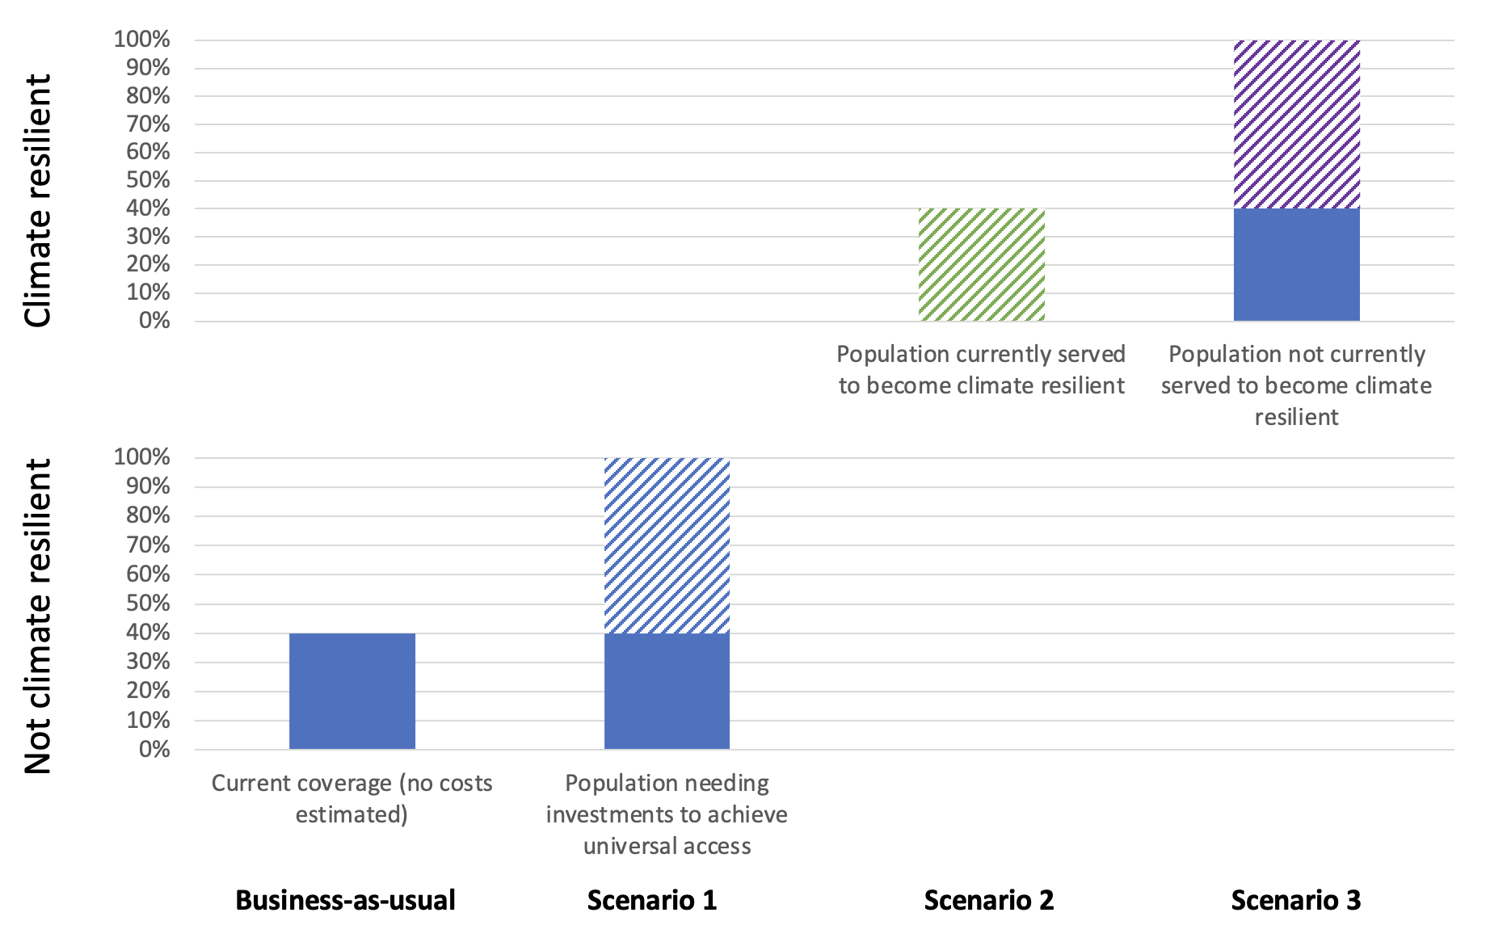
An overview of key variables for the calculations is provided in Box 2.
Box 2. Key variables for calculation of incremental costs for achieving resilience to droughts
Incremental cost = Population exposed (numbers) x Cost premium (US$)
Population exposed = Water stress (by scenario) x Urban population exposed
Cost premium (US$) = Cost premium (%) x Baseline cost (US$)

The additional costs of ensuring urban water services are resilient to water scarcity and droughts depends on the drought risk and severity of drought. Drought risk depends on the degree of global warming according to the Representative Concentration Pathways (RCP). Drought risk for each country is obtained from the Aqueduct Water Risk Atlas (Aqueduct 4.0), managed by the World Resources Institute. The estimates curate 13 water risk indicators—spanning quantity, quality, and reputational concerns—into a comprehensive framework. Each indicator is sourced from an open-source, peer-reviewed data provider and then transformed to normalized risk score based on the severity of the water challenge (Kuzma et al, 2023). Drought risk is proxied by water stress, which is an indicator of competition for water resources and WRI defines it as the ratio of demand for water by human society divided by available water. Water stress has 5 categories: low, low to medium, medium to high, high and extremely high. In the baseline analysis, any location that has medium to high or above is considered as needing measures to strengthen climate resilience by 2050. In scenario analysis, populations in the medium-to-high risk category are included.
The Aqueduct Water Risk Atlas was used instead of the World Bank climate change knowledge portal due to the CCKP currently not being able to produce simple risk outputs for all countries. Drought risk could be based on the Standardized Precipitation Evapotranspiration Index (SPEI), which has values from -3 to 3, with different negative values indicating different severity of drought. However, there is no SPEI value which has been defined to mean urban service providers have to take measures to reduce the drought risk.
The Aqueduct Water Risk Atlas presents data for all 131 countries included in this present study, except several Pacific Islands (Kiribati, Marshall Islands, Micronesia, Palau, Samoa, Tonga and Tuvalu), Maldives, Mauritius, Guyana, Cape Verde. Urban populations in these countries were assumed to be at low risk of water stress based on data from other similar island locations.
It is assumed that few, if any, water providers in L&MICs have already made their services resilient to the increased risk of droughts over the coming 30 years. Hence, for those countries facing heightened drought risk due to climate change, 100% of service providers are required to invest to make their services resilient to drought.
The costs of making urban water services more resilient to droughts depends on which solutions are selected and what are their (relative) costs, as instructed in a World Bank brief on resilient water infrastructure design (World Bank, 2020). Across 131 L&MICs, the solutions chosen will be very different given the different risks, technology options and water sources in each country. For example, the World Bank’s Water Scarce Cities report shows how different cities have found different solutions to augment water supply, including local groundwater, local surface water, treated wastewater reuse, rainwater/stormwater harvesting, and desalinization. Cities in extremely water scarce locations have also had inter-basin transfers of groundwater and surface water. Similarly, Salameh et al (2021) and UNICEF (2022) compare several options in Jordan: investment in household water storage to overcome intermittent supply; agricultural water use efficiency; desalinization; and water management (reduction in illegal abstraction).
Equally if not more important to augmenting water supply will be measures to reduce water use and wastage, both in domestic and non-domestic settings (Dilling et al, 2019). The latter will be particularly important given agricultural and industrial water use accounts for at least 90% of freshwater withdrawals in most developing countries. As of 2019, the global average non-revenue water (NRW) rate stood at 30% or 126 billion m³, equating to financial losses of an average of US$39 billion a year (cited in Liemberger and Wyatt 2019). Ways of reducing domestic use include:
- Reducing non-revenue water, given it represents between 25% and 50% of the total water supply and, in some developing countries, accounts for up to 75% of the total water supply (IWA 2015). Therefore, there is very considerable potential to reduce NRW without having to augment the support or manage demand in many countries. Addressing NRW also improves the financial viability of water service providers. On the other hand, reducing NRW may not fully address the longer-term water scarcity that may affect some countries or cities.
- Demand management – this is traditionally split into price-based and non-price-based water demand management.
  - Pricing-based: reducing water use through increasing the tariffs achieves twin goals of demand management and cost recovery. However, various knock-on impacts should be noted, including making water less affordable for many households and reducing the use of water for productive purposes. Furthermore, for price-based measures to be effective, metering is necessary which is costly and can be challenging in some settings. In case of emergency measures, tariffs can be used to incentivize lower water consumption and penalize higher water consumption as was modelled in Brazil (Silva Pinto et al, 2021).
  - Non-pricing-based: includes introduction of water-efficient devices (e.g., low flush toilet), raising public awareness to reduce less necessary water usage and reduce wastage, and introducing mandatory or voluntary water use restrictions.
Several successful water saving schemes are presented by Arup, but the examples are from developed countries and do not have the associated costs attached. Unfortunately, there are very few studies from L&MICs presenting the unit costs of augmenting water supply or reducing water use. As noted in the World Bank’s ‘Lifelines’ publication: “A global analysis of the exposure of all water infrastructure to natural hazards was impossible because of a lack of global data on water sector assets” (Hallegatte et al, 2019). Also noting that another World Bank study on global infrastructure costs conducted the same year (Rozenberg and Fay, 2019) did not allow for the impacts of climate change due to the empirical challenges involved and lack of data.
Several studies have focused on the costs of individual households taking measures to augment water supply when it is unreliable; however, this is not the focus of the present study, which is to assess system-wide measures that can be implemented by the water supply authorities or water provider.
Cost studies are presented below under three headings: global studies, published country studies, and World Bank country operations.
Global studies. The World Resources Institute estimates the global cost of eliminating water scarcity by reducing the ratio of water demand (human and environmental) to renewable water supply to within acceptable boundaries (SDG 6.4) (Strong et al, 2018). Their analysis covers rural and urban areas with no breakdown between them. The study identified the overall water supply gap and assessed which sectors water savings are needed from, and the cost per cubic meter of making those savings per sector, using cost curves and selecting the cheapest method(s) that achieves water savings (see Appendix A in Strong et al (2018) – section on SDG 6.4 Water Scarcity). They find that addressing water scarcity totals US$445 billion (2015) annually and represents 43% of the total annual cost of achieving SDG 6. The most cost-effective solutions to water scarcity exist on the demand side rather than the supply side. Regionally, the largest costs are in North America and in East Asia and the Pacific. Relatively speaking, sub-Saharan Africa and Latin America and the Caribbean have lower water scarcity costs.
Hughes et al (2010) estimate the adaptation costs for different components of water supply and sewer systems in OECD countries (see Table 1). For the wettest scenario (NCAR) the water resources cost increases by 30% from US$915 to US$1,187 billion, while for the driest scenario (CSIRO) the water resources cost increases by 14% from US$915 to US$1,043 billion. The percentage change varies from region to region, being greatest in Western Europe for NCAR scenario and for Eastern Europe for the CSIRO scenario. In terms of the drought risk, the cost to access water resources is considered to be the appropriate component for the cost comparison.

Table 1. Adaptation costs for different components of water supply and sewer systems in OECD countries
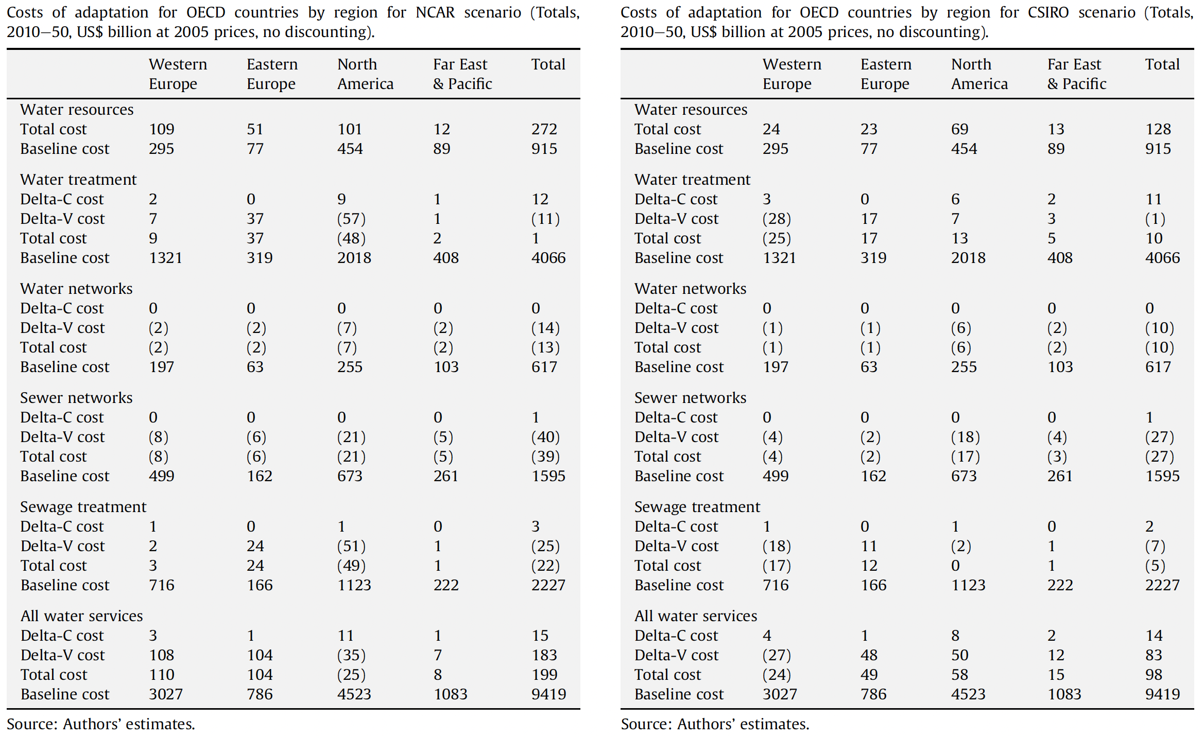
Source: Hughes et al (2010)

Country studies. Ribeiro et al (2022) estimate the costs of augmenting water supply from five different sources in one city in Brazil. As can be seen in Figure 2, the unit costs vary significantly between options, from a fraction of US$ 1 per cubic metre extracted from groundwater to almost US$4 per cubic metre of greywater treated and reused. This compares to approximately US$0.7 per cubic metre for domestic water and wastewater. Hence, using wastewater reuse or desalinisation more than doubles the cost of water supply.
Figure 2. Costs of augmenting water supply from five different sources in one city in Brazil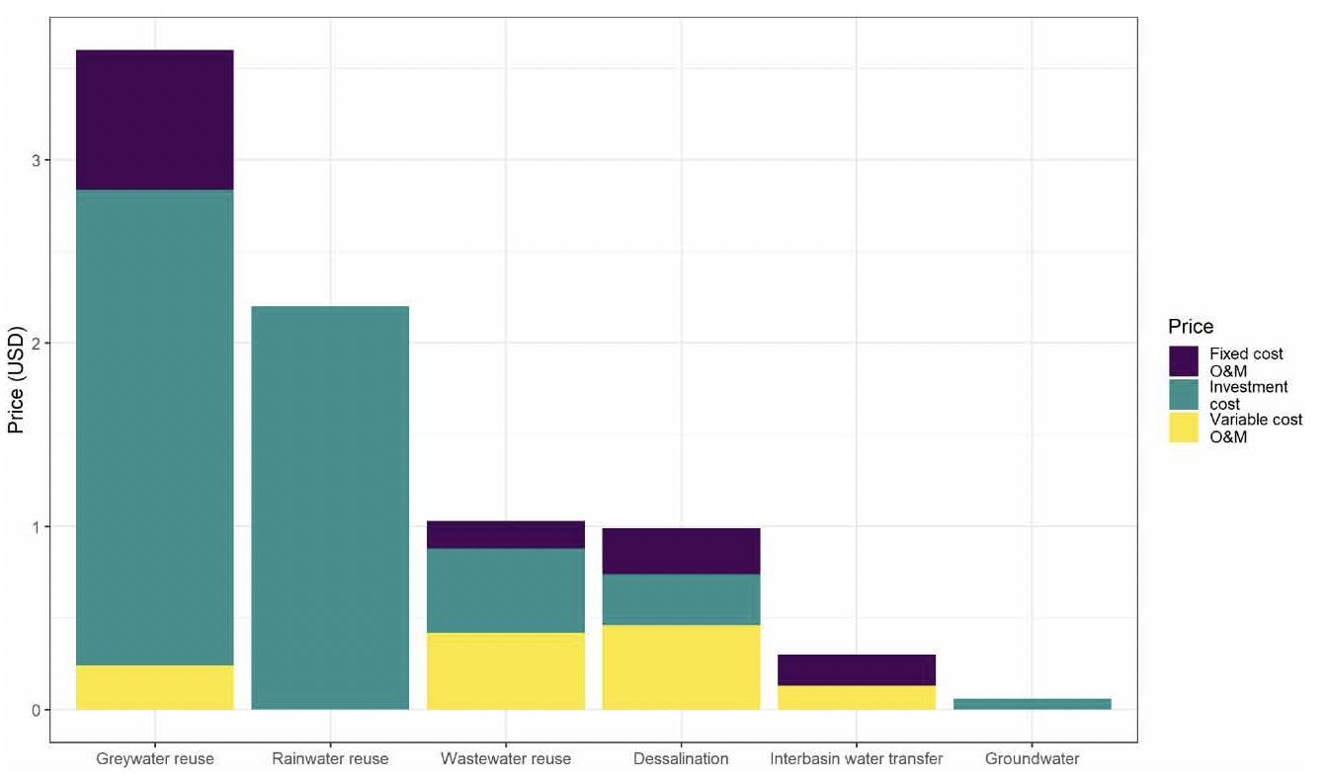
Source: Ribeiro et al (2022)
Decker (2018) estimates the average incremental cost for a range of measures to make water services more drought resilient in the UK. Together, the preferred measures are estimated at around £0.60 per m³ - and they are similar between the average incremental cost (AIC) and the average incremental social cost (AISC). These preferred measures are selected from a wider range of feasible options, where the social and environmental cost is greater at 9.3 pence (£1.074 minus £.981). In comparison to the cost per cubic meter in the same period of £1.7 to £2.2, the incremental cost represents about 27% to 35% additional cost.
Table 2. Average incremental cost for measures to make water services more drought resilient in the UK (£)
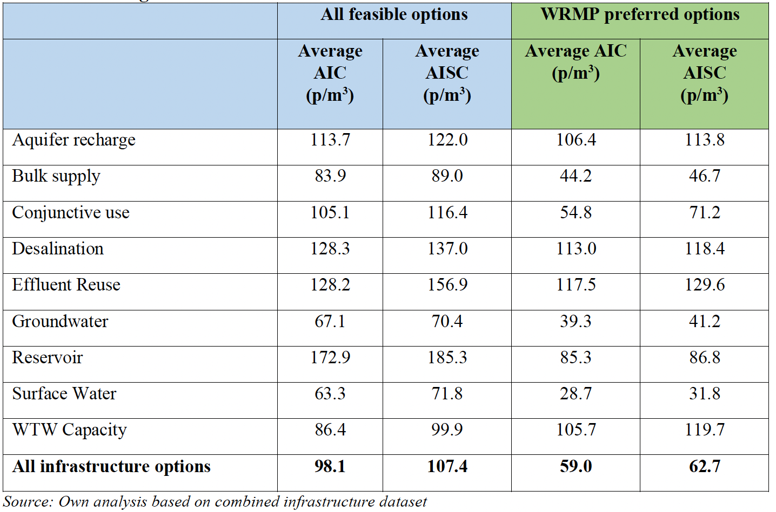
Source: Decker (2018)

Heyman et al (2022) estimate the increase in costs of providing the needed water for El Paso city in Southwest USA. The costs increased considerably as more expensive ways of augmenting water supply were used. Between 2020 and 2040, the total costs will more than double those of the baseline, if the more expensive water sources need to be used (see Figure 3).
Figure 3. Annual water supply costs and aggregate fraction of income spent on water for service area for each scenario from 2020-2070 (El Paso city in Southwest USA)
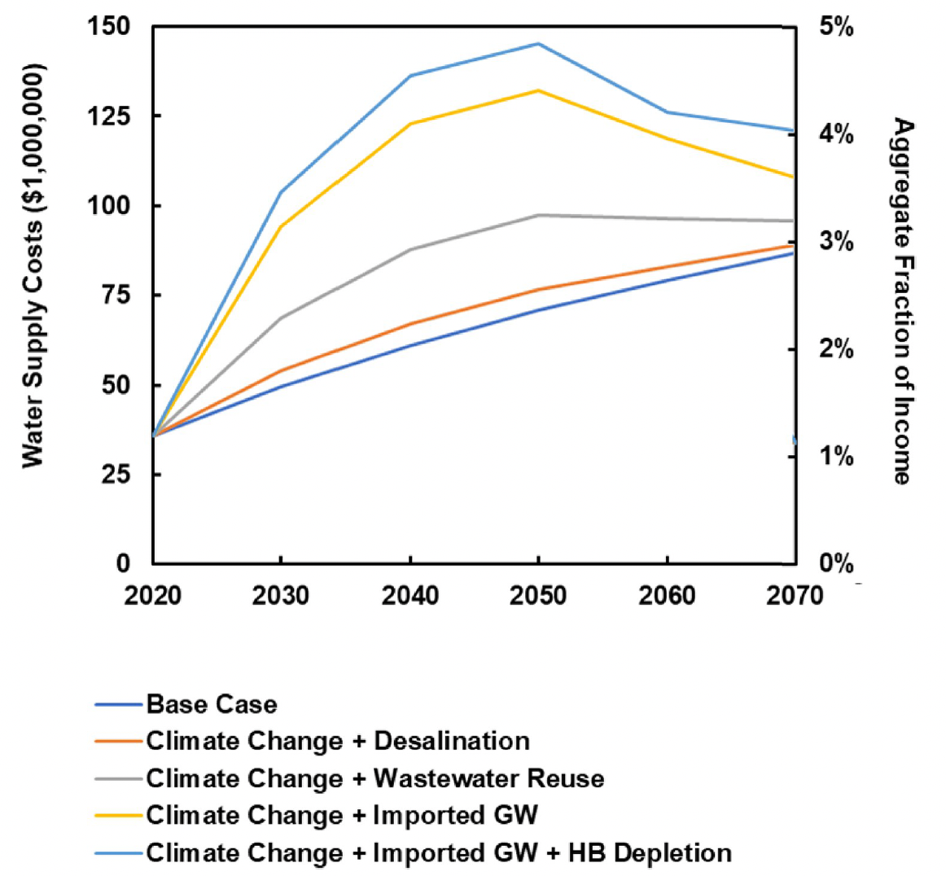
Source: Heyman et al (2022)
World Bank country operations. Task Team Leaders of over 90 World Bank operations were approached to request cost data of implementing measures to increase climate resilience of water services in urban settings. Of the replies received, very few had any usable data to inform this present study. The results of one study collected from operations of the World Bank are presented in Table 3.
Table 3. Incremental cost estimates of making water infrastructure resilient to droughts, from World Bank operations
Intervention | Cost | Country
Bi-directional flow of the primary water delivery pipeline | Adds 8.75% to the overall project cost | Eswatini

Summary: Based on these published and unpublished cost studies, an average cost premium is estimated for increasing resilience to drought in vulnerable cities. The proportion of urban population that will require greater drought resilience is determined by the three SSP climate scenarios. Given that the cost premium varies for different parts of the water sourcing, production and distribution process, the proportional contributions of different parts of the water supply service chain are needed to calculate the total incremental cost:
- Water source: 30% of costs
- Conveyance to treatment plant: 20% of costs
- Treatment plant: 30% of costs
- Distribution to households: 20% of costs
The following water sources are selected by water providers. Reservoirs require long transmission in pipelines, while the other sources requite short/local transmission in pipelines or canals (see Table 4):
- Reservoirs – 30%
- Storage tanks – 20%
- Groundwater – 30%
- Surface water – 10%
- Desalinization – 10%
The values cited above are likely to vary considerably between urban areas within a single country (if diverse climate, topography, etc.) and between countries. Hence results presented at a country level risk being inaccurate, while results at regional level are more likely to conform with the above averages. In sensitivity analysis, the cost proportions were varied to be less costly to obtain the raw water (10%, 10%, 50% and 20%, respectively); while the water sources were varied to be more groundwater intensive (10%, 10%, 60%, 20%, 0%, repectively).
Next, the cost premiums for increasing drought resilience for different parts of the water value chain are needed. Global studies varied from 14% to 43% incremental cost, while national studies varied from 8.7% to 30% to more than 100%. The cost premium is multiplied by the baseline cost for each part of the water value chain separately (provided above). In all cases, the water sources will need to be supplemented, adding between 20% and 100% of the baseline cost depending on the source. Incremental conveyance costs account for 20% of the baseline conveyance costs. For surface water that is treated, it will add 50% to the treatment cost. Measure to reduce non-revenue water are expected to cost 20% of the distribution costs. Measures to affect household behavior are expected to cost 10% of the total cost of water supply provision.
Table 4. Cost premiums for building resilience to drought
Part of water value chain | Specific measure | Cost premium on baseline cost
Water source | Sourcing from distant reservoirs | 40%
Water source | Sourcing from storage tanks/ponds | 20%
Water source | Sourcing and pumping groundwater | 20%
Water source | Treating surface water or reusing wastewater | 50%
Water source | Sea water (desalinization) | 100%
Conveyance to treatment plant (additional conveyance routes) | Pipeline (long transmission) | 30%
Conveyance to treatment plant (additional conveyance routes) | Pipes or canals (short transmission) | 10%
Distribution to household | Reduce non-revenue water | 20%
Household use | Pricing measures (metering) | 10%
Household use | Non-pricing measures (awareness) | 10%
Source: author estimates

2.4 Costs of protecting water infrastructure against flood risk
A flood is an overflow of a large amount of water beyond its normal limits, especially over what is normally dry land. Floods cause massive socio-economic losses through damage to property and equipment, and prevention normal activities and operations. While floods cannot always be prevented, their impact can be reduced or minimised by making appropriate choices at infrastructure development phase, as well as a series of good practices (e.g., reducing clogging of urban drains). To avoid unnecessary additional costs in already budget-strapped contexts, the ’right’ amount of adaptation is needed, based on reliable climate data and comparing the costs and effectiveness of the programmatic and technology options available.
The methodology for estimating the costs of achieving universal coverage of water services was described in section 2.2. Two additional coverage scenarios are assessed to protect urban populations from floods:
- Costs of upgrading current population coverage of urban water services, to achieve greater resilience to floods. This scenario focuses on the existing water services infrastructure only. Separate cost estimations are made for increasing flood resilience for basic and for safely managed water services. Those with below basic are brought to the basic level of access with flood resilience.
- Costs of ensuring new and expanded water services have greater resilience to floods. This covers the incremental cost of achieving climate resilience on top of the universal access costs described in section 2.2, covering only the population that are unserved in 2022. Separate cost estimations will be made for basic and for safely managed water services.
By comparing these three scenarios, they are implicitly comparing with a ‘no new investment’ business-as-usual scenario, whose investment cost is zero. Figure 1 (earlier) provides a visual presentation of the population covered in the three scenarios. An overview of key variables for the calculations is provided in Box 3.
Box 3. Key variables for calculation of incremental costs for achieving resilience to floods
Incremental cost = Population exposed (numbers) x Cost premium (US$)
Population exposed = Flood risk (by scenario) x Urban population exposed
Cost premium (US$) = Cost premium (%) x Baseline cost (US$)

The additional costs of ensuring urban water services are resilient to floods depends on the flood risk and severity of flood. Coastal flooding and riverine flooding are separately evaluated under RCP 4.5 and RCP 8.5 for the year 2050 with a 1 in a 100 year return period. Riverine flooding draws on GFDL /NOAA data. Administrative layers in the database were dissolved to get GADM at the admin 0 level. Flood was classified as follows (Rentschler et al, 2022):
- “No risk”: areas that are estimated to remain unaffected during 100-year floods;
- “Low risk”: inundation depths of up to 0.15 meters;
- “Moderate risk”: inundation depths of up to 0.5 meters;
- “High risk”: inundation depths of up to 1.5 meters;
- “Very high risk”: inundation depths above 1.5 meters
In the WRI Aquaduct database, the “reclassify” tool was used to categorize the flood layers into ‘moderate’ flood risk (flood depth greater than 0.5 metres but less than 1.5 metres) and ‘high’ flood risk (flood depth greater than 1.5 metres). The value for each country is converted to a proportion (%) of population facing a moderate or higher flood risk and high risk or higher flood risk. The proportion of urban population that will require greater flood resilience is determined by the two RCP climate scenarios (4.5 and 8.5). In the results section, to be consistent with the drought analysis, the RCP climate scenarios are presented to approximate SSP2 and SSP3, respectively.
The costs of making urban water services more resilient to floods depends on which solutions are selected and what are their (relative) costs, as indicated in a World Bank brief on resilient water infrastructure design (World Bank, 2020). Across 131 L&MICs, the solutions chosen will be very different given the different risks, technology options and geophysical features.
It is assumed that few, if any, water providers in L&MICs have already made their services resilient to the increased risk of floods over the coming 30 years (see endnote xviii). Hence, for those countries facing heightened flood risk due to climate change, 100% of service providers are required to invest to make their services resilient to flooding.
Given that the cost premium varies for different parts of the water sourcing, production and distribution process, an average proportion of costs is assumed, as follows:
- Water source: 30% of costs
- Conveyance to treatment plant: 20% of costs
- Treatment plant: 30% of costs
- Distribution to households: 20% of costs
A study conducted by Miyamoto (2019) for the World Bank estimates the cost premium for protecting water services from increased risks of flooding, presented in Table 5. The study looked at both (a) engineering improvements such as taller dam structures, elevation of water treatment plants and fortifying buildings; and (b) quality improvements such as quality of construction, construction inspection, maintenance, dredging/drainage. The cost premium is multiplied by the baseline cost for each part of the water value chain separately (provided above). The Miyamoto (23019) study modelled for a ‘large’ flood event, which it is suggested in other parts of the report is between 2 and 3 feet high. Therefore, a flood event of greater than 1.5 metres will need additional protection. It is expected that the costs will increase non-linearly for larger flood events. Therefore, for high flood risk, it is assumed the costs are between 2 and 3 times greater than the moderate flood risk (see Table 5).
Table 5. Cost premiums for building resilience to floods
Part of water value chain | Specific measure | Cost premium on baseline cost
Part of water value chain | Specific measure | Moderate risk | High risk
Water source | Sourcing from distant reservoirs | 5% | 15%
Water source | Sea water (desalinization) | 5%* | 15%
Conveyance to treatment plant | Protect pipelines from flooding | 2% | 6%
Conveyance to treatment plant | Protect open canals from flooding | 15% | 30%
Treatment plant | Protect treatment plant from flooding | 5% | 15%
Distribution to household | Protect pipelines from flooding | 2% | 6%
Source: Miyamoto (2019) for moderate risk. For high risk, assumed values.
* Not included in Miyamoto (2019) but assumed to be the same as for water treatment plants

2.5 Costs of expanding wastewater treatment
The focus of the wastewater treatment analysis is on household (domestic) wastewater, including both grey and brown wastewater streams. This is for two main reasons. First, there is limited global data reported on the volume of industrial wastewater that is generated and treated. Global reporting by UN-Water for L&MICs ignores agricultural wastewater/run-off and other sources of wastewater. Second, from a public finance perspective, the decision to focus on domestic wastewater can be justified by the fact that industry will be (or should be) expected to cover the majority of wastewater treatment costs.
Currently only about 42% of domestic wastewater is treated in developing countries. This means that 58% of domestic wastewater is returned untreated to the environment, causing environmental impacts and generating greater greenhouse gas emissions. Furthermore, the 42% of domestic wastewater that is treated is done so in a sub-optimal way, both from the climate mitigation angle and from the environmental pollution angle, given most of the treatment is partial. It is therefore important to estimate the costs of expanding access to environmentally friendly wastewater treatment approaches, as well as retrofitting existing facilities where there is an economic and environmental rationale.
Scenarios. Three scenarios are assessed for their costs, covering both investment and operations and maintenance (O&M) costs:
- Retrofitting existing wastewater treatment facilities to reduce the GHG emissions per cubic metre of wastewater that is currently treated. Technologies are considered that already exist and can be deployed on a large scale.
- Treating all untreated wastewater using wastewater treatment methods that currently exist that reduce the GHG emissions per cubic metre of wastewater treated. This scenario includes the costs of wastewater collection and conveyance for the proportion of wastewater that is currently not collected, plus the costs of treating all wastewater using treatment methods that generate lower GHG emissions than current treatment methods. Hence scenarios 1 and 2 can be added together to estimate the total costs.
- Treating all untreated wastewater based on the assumption that SDG target 6.1 on water supply is achieved, leading to the generation of 100 litres per capita per day (lpcpd) of wastewater. In some countries currently with over 100 lpcpd of wastewater, this will mean an average reduction in wastewater, while for countries currently with under 100 lpcpd of wastewater, this will mean an average increase in wastewater. This scenario is an alternative to scenarios 1 and 2 combined.
For simplicity, these three options are compared for immediate achievement of the target coverage in the year 2024 in terms of their total costs. Results are presented globally and by World Bank world region. Based on these numbers, future analyses can estimate cumulative GHG savings and costs over a longer time period – to meet carbon emissions targets in later years.
Wastewater generation and treatment. The United Nations Environment Programme (UNEP) and WHO are custodians responsible for monitoring SDG target 6.3 on wastewater. The SDG indicator 6.3.1 is reported by UN-Water. Global monitoring systems report total wastewater generated from domestic sewage, septic tank and other sanitation systems separately, and of these, the proportion collected and the proportion safely treated. The total wastewater generated and collected is available for all 131 L&MICs included in this study, while data on wastewater treated is available for at least half L&MICs. For those countries lacking data, regional averages are applied to generate the figures shown in Table 6. Currently, the proportion of global household wastewater safely treated is 55.3% in 2021, while for L&MICs it is approximately 41.8%.

Table 6. Domestic wastewater generated and treated, by developing world region
Region | WW generated | WW treated | Percent of WW treated
Latin America and the Caribbean | 25,449 | 11,026 | 43.3%
Sub-Saharan Africa | 18,881 | 3,698 | 19.6%
Middle East and North Africa | 15,749 | 7,739 | 49.1%
Europe and Central Asia | 10,805 | 4,153 | 38.4%
South Asia | 39,170 | 9,195 | 23.5%
East Asia and the Pacific | 72,229 | 40,412 | 55.9%
Total | 182,284 | 76,223 | 41.8%
Note: The table includes 131 countries covered in this present study.
Source: UN-Water https://www.unwater.org/our-work/integrated-monitoring-initiative-sdg-6/indicator-632-proportion-bodies-water-good-ambient

Cost estimates. Two monitoring initiatives that encompass both water and wastewater collect information from selected utilities globally: the Global Water Intelligence and the World Bank’s IBNET. The GWI data set is judged to be the most up-to-date data set providing unit cost per cubic meter of wastewater treated, with a critical mass of L&MICs submitting unit cost data from at least one utility. In addition to these data sources, one UN report details costing methods and studies of wastewater treatment, from which several studies were selected for this review (Hernández-Sancho et al, 2015). This publication also provided parametric cost functions and cost per metre of pipeline and other cost information which could not be used for this global study.
The existing literature is weak how climate change will impact the costs of treating wastewater. A case study on China (Hu et al, 2019) reported in World Bank “Lifelines” report (Hallegatte et al, 2019) finds that climate change will significantly increase the exposure of Chinese wastewater treatment plants (WWTPs) to floods, even over the short term, with large potential impacts on users. The Miyamoto (2019) study cited in section 2.4 estimated benchmark for cost increases – a 40% increase in pumping and conveyance cost and a 5% increase in cost to elevate the structure of wastewater treatment plants.
The investment and O&M costs for wastewater conveyance and treatment were obtained from the GWI database and compared with the published literature. Data were available for 83 out of 131 L&MICs. For countries with no data, the regional average unit cost was transferred to the country using the ratio difference in GDP per capita at PPP. As the GWI database is not publicly sharable, input data are not provided here. As the GWI database did not break costs down by lifecycle capital and O&M costs, the literature was revised to assess the approximate breakdown. However, there is considerable variation in different studies on what proportion of cost per cubic meter are capital versus O&M costs. For decentralised WWTP systems, Pryce et al (2022) found that capital cost accounted for 11.9% of total lifecycle cost. Prateep et al (2022) assume lifecycle capital costs and O&M costs to be the same. Moral-Pajares et al (2019) estimate capital costs to be 19.3% of lifecycle costs. This study assumes 20% of lifecycle cost are capital costs.
The challenge in choosing unit costs for future technologies which will reduce GHG emissions is the lack of underlying cost studies clearly distinguishing technologies by their GHG emissions. Many studies evaluate GHG emissions of different wastewater treatment technologies, but these do not include costs. Some studies present costs of different technologies – as documented in this study – but do not present GHG emissions by technology. Hence, there is a limited basis for matching costs by technologies ranked by the GHG emissions. A review of the literature on WWTP costs revealed differences between different technologies. Given that the majority of WWTPs globally provide primary treatment (1.5%) or secondary treatment (59.2%), and therefore most WWTPs in L&MICs are likely to be primary or secondary treatment (Ehalt Macedo et al, 2021) and have higher GHG emissions from released treated wastewater than advanced technologies (Wang et al, 2022). Therefore, a comparison of the costs of simpler versus more advanced WWTP technologies is made, as follows.
In France, Berland and Cooper (2001) found that capital cost varied from €0.120 for waste stabilisation ponds per person equivalent to €0.23 for activated sludge; similarly, annual operations costs varied from €5.5 to €11.5 per 1,000 person equivalents for the same technologies. In Spain, Rodríguez-Garcia et al (2011) report that WWTPs that remove organic matter and discharge treated wastewater to non-sensitive areas had an operating cost of €0.12 per m³ compared to WWTPs that treat wastewater to quality levels for agricultural or industrial reuse at €0.26 to €0.28 per m³. Sekandari (2019) in Afghanistan found that annual O&M and labor cost for activated return sludge treatment plant (ARSTP) was twice that of waste stabilisation ponds. Similarly, construction cost was almost twice that of ARSTP. In Belgium, Dogot et al (2010) found trickling filters had the lowest operational cost (31 €/p.e) followed by the aerated lagoon (34 €/p.e), then activated sludge (45 €/p.e), then biodisk (48 €/p.e). On investment costs, Iglesias et al (2010) report vastly different costs for different types of technology for wastewater reuse from €9 per m3 per day for filtration and disinfection to €48 per m3 per day when a simple lamella settling system is added.
Based on these examples, it is clear that additional resources will need to be spent in L&MICs to reach higher environmental standards, both from the pollution and the GHG perspectives. However, there is a trade off between meeting stricter pollution standards and achieving reductions in GHG emissions. Better conveyance methods and more advanced treatment can reduce the GHG emissions of the treated wastewater when it is reused or returned to the environment; however, some highly advanced treatment methods can significantly increase GHG emissions, too, as well as involve significantly higher costs. Therefore, assessments need to be conducted in each location of the costs and GHG emissions of different technologies to select the appropriate ones. Based on the literature, it this analysis assumes that both capital costs and O&M costs need to be double those of current technologies and standards, in order to treat more wastewater and do it without increasing GHG emissions. In sensitivity analysis, an incremental cost of 50% instead of 100% higher is explored.
The costs were further adapted to reflect the cost premium of increasing flood resilience of wastewater treatment plants and sewerage networks. For ensuring sewerage networks and WWTPs are resilient to the higher risk of flooding in some geographies, cost premiums were taken from Miyamoto (2019) – an additional 40% for conveyance cost, and an additional 5% to elevate and improve construction quality of wastewater treatment plants. These premiums were added only for the populations at risk of flooding under SSP3 (see section 2.4).

2.5 Combined costs
The scenarios described in prior sections are combined to produce the costs of achieving different outcomes. In Table 7, numbers listed 1 to 5 are mutually exclusive. Numbers 2 to 5 address climate resilience. Numbers 1 to 5 together to estimate the total cost of achieving universal access that is climate resilient.
Table 7. Scenarios presented in the results
Scenarios | Climate scenarios | Climate resilient? | Lower GHG emissions?
- Costs of achieving universal access to urban water supply | SSP1, SSP3, SSP5 | No | No
- Costs of increasing wastewater treatment to 100% coverage | SSP2, SSP3 | No | No
- Costs of retrofitting existing water services | SSP1, SSP3, SSP5 | Yes | No
- Costs of retrofitting existing wastewater services | SSP2, SSP3 | No | Yes
- Costs of ensuring new water services are climate resilient | SSP1, SSP3, SSP5 | Yes | No
- Costs of ensuring new wastewater services have low GHG emissions | SSP2, SSP3 | No | Yes
- Ensuring new wastewater services (in 6.) are flood resilient | SSP2, SSP3 | Yes | N/A
- Total costs (sum 1- 7) | SSP3 | Yes | Partial
- Total costs of climate resilience (sum 3-7) | SSP3 | Yes | Partial
N/A – not applicable

2.6 Current investments in water and wastewater
Current (or recent) expenditure estimates were made in two ways: (1) reported expenditures from global reporting systems, and (2) estimated expenditures based on rates of coverage progress from 2015 to 2022. The methodologies are explained below.
Reported expenditures from global reporting systems. Expenditure data were collected from the UN-Water GLAAS survey 2021/22, given it is government-reported data for a large number of countries. Question D2 in the survey asks for estimates of government budgets specific to WASH, split by water, sanitation, hygiene and WASH in institutions. Most governments reported for the year 2020 or 2020/2021, depending on the fiscal year. However, there is no breakdown by capital/recurrent budget, neither by rural and urban area. Some countries present only the total WASH budget. These gaps in information for urban water supply budgets were dealt with by: (1) allocating 90% of the WASH budget to water supply when there is no breakdown; and (2) presuming urban areas receive 70% of the public budget for water compared to 30% for rural areas.
Furthermore, the GLAAS survey question D10 covers sufficiency of budget/expenditure for urban drinking-water, comparing the cost versus the current expenditure. These questions were answered by about 1/3 of respondents (about 30-40 countries), while many other countries answered the % adequacy of resources without providing underlying figures. Several countries benefit from applying WASH Accounts or conducting a Public Expenditure review.
The GLAAS report also presents a summary of aid expenditure using the OECD’s CRS database, which can be accessed from the CRS database by country.
Estimated expenditures based on rates of coverage progress from 2015 to 2022. This method identifies the progress in basic and safely managed water supply coverage in urban areas from 2015 to 2022, and estimates what would need to have been spent to achieve this progress. It uses the unit costs for capital and O&M from the updates from Hutton and Varughese (2016) described in section 2.2. Data gaps in safely managed water service coverage are filled by using the lowest of the available 3 components to determine safely managed water supply.

3. Results

3.1 Topline results
This section presents key results under 3 climate change scenarios, with a 2040 target year for achieving universal coverage and climate resilience. Costs are presented as annual averages, using a 6% discount rate.
Overall results. Table 8 shows the annual costs of achieving different targets, under SSP3 (as SSP3 is the common SSP modelled across drought and flood risk) covering 131 low- and middle-income countries (L&MICs) across 6 world regions. The costs of closing the service coverage gap to achieve universal access is US$71.1 billion a year for urban water and wastewater combined. 65% of this value is required for wastewater services, explained by the fact that only 42% wastewater treatment coverage has been achieved compared with >60% coverage for safely managed water supply in L&MICs.
The incremental costs of retrofitting existing water and wastewater facilities equals US$18.1 billion, or an increase on baseline costs of 25.4%. The incremental costs of ensuring new water and wastewater facilities for unserved populations are climate resilient will cost US$2.5 billion per year, or an increase on baseline costs of 3.5%. Together, the incremental costs are US$20.6 billion, or an increase on baseline costs of 28.9%. Ensuring lower emissions of new wastewater services costs US$27.1 billion.
The total costs of achieving adaptation and mitigation of new and existing services to reach universal coverage is US$118.8 billion per year, with climate resilience costing an additional 40.1% on top of the baseline costs using business-as-usual interventions.
If just climate resilience of water supply services is considered, it adds to US$3 billion, which is within the additional $2 billion to $5 billion a year the World Bank estimated would be required to make all water assets more resilient (Hallegatte et al, 2019).
The current spending on urban water supply of US$19 billion a year covers 77% of the current needs under business-as-usual, and 68.8% of the costs of also achieving climate resilience. However, as the majority of current spending is spent on operating existing services, and not extending services, the finance gap is significantly greater.
Table 8. Annual costs of achieving different outcomes (US$ million)
Scenarios | Annual cost (million)
Scenarios | Capital | O&M | Total | Combined
1. Universal access to urban water supply | $9,144 | $15,522 | $24,666 | $71,108
2. Increase wastewater treatment to 100% coverage | $9,288 | $37,154 | $46,442 | $71,108
3. Retrofitting existing water services | $260 | $879 | $1,139 | $18,056
4. Retrofitting existing wastewater services | $3,344 | $13,573 | $16,917 | $18,056
5. Ensuring new water services are climate resilient | $715 | $1,161 | $1,876 | $2,503
6. Ensuring new wastewater services are flood resilient | $125 | $501 | $627 | $2,503
7. Ensuring lower emissions of new wastewater services | $5,419 | $21,675 | $27,094
8. Total costs (1+2+3+4+5+6+7) | $28,296 | $90,464 | $118,760
9. Total costs of climate resilience (3+4+5+6+7) | $9,864 | $37,789 | $47,652
Percent achieving climate resilience over baseline | 34.9% | 41.8% | 40.1%
Current spending on urban water supply (estimated) |  |  | $19,000
Achieving universal access with no or limited adaptation. Figure 4 presents costs of achieving universal access to safely managed water supply in urban areas by world region under SSP1. The overall costs for 131 L&MICs are US$10.2 billion per year for capital costs and US$17 per year for O&M until 2050, assuming that universal coverage is achieved in 2040. The annual per capita costs across all L&MICs averages US$2.2 and US$3.6 for capital and O&M, respectively. The region with the highest total and per capita costs is sub-Saharan Africa, with a total cost of US$11.15 billion per year, or US$12.9 per capita per year.
Figure 4. Costs of achieving universal access to safely managed water supply in urban areas by 2040 with O&M until 2050 – total annual costs (left side) and per capita annual costs (right side)
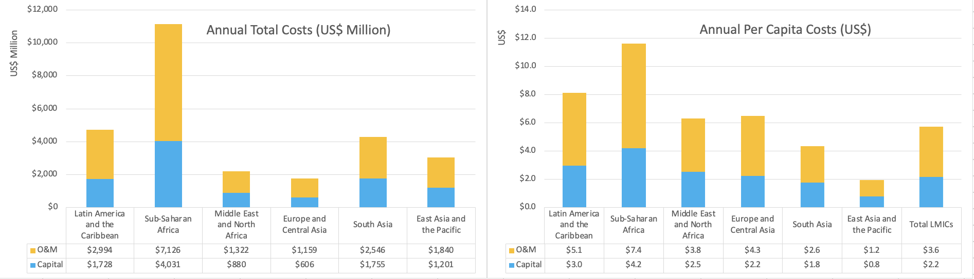

Figure 5 compares the capital costs of achieving universal access to urban water supply under different SSPs, showing there is not a large difference globally, though there is some regional variation. The differences are driven purely by the different population projections for 2050. Global costs range from US$9.1 to US$10.2 billion per year for capital costs and from US$15.5 to US$17.0 billion per year for O&M costs.
Figure 5. Capital costs of achieving universal access to safely managed water supply in urban areas by 2040 under three Shared Socioeconomic Pathways
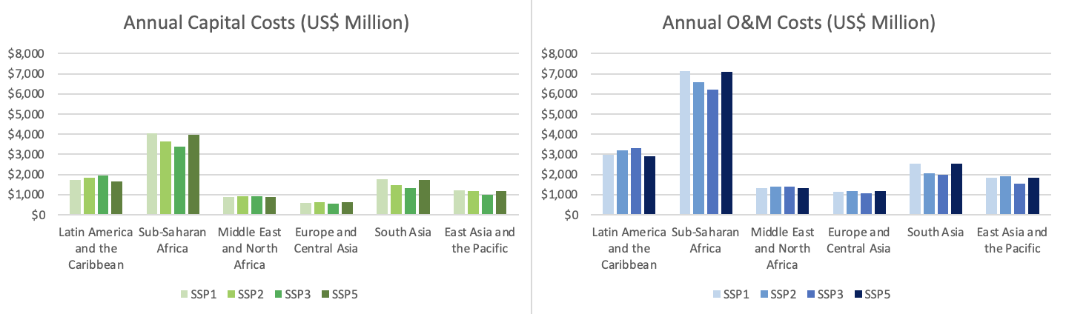

When comparing the capital costs of US$10.2 billion per year from this study with the previous World Bank study (Hutton and Varughese, 2016) – which reported urban water supply costs of US$23.8 billion per year from 2016 to 2030 – the annual costs are lower in this present study, which can be largely explained by the fact that in the former study 2 billion people in urban areas were to gain access within 15 years whereas the present study 1.19 to 1.43 billion people are to gain access in 27 years (the number depends on the SSP scenario).
Costs of sourcing water to mitigate drought risks. Figure 6 presents the annual costs of making existing safely managed water supply services climate resilient in urban areas. The annual capital costs in 131 L&MICs until 2050 is between US$233 and US$246 million under different SSPs. The O&M costs are between 3 and 4 times higher, between US$788 and US$834 million under different SSPs. Globally, this represents only an increased in cost of 2.4% for capital and 8.5% for O&M as a proportion of the annual costs of achieving universal access (from Figure 1). However, this global average hides large regional variation – with 9.5% increased capital cost in MENA and 5.8% increased capital cost in EAP (and double these increases for O&M costs), the two regions accounting for the greater cost proportions.
Figure 6. Annual costs of reducing drought risk for existing safely managed water supply services in urban areas by 2040, with O&M until 2050 – capital costs (left side) and O&M costs (right side)
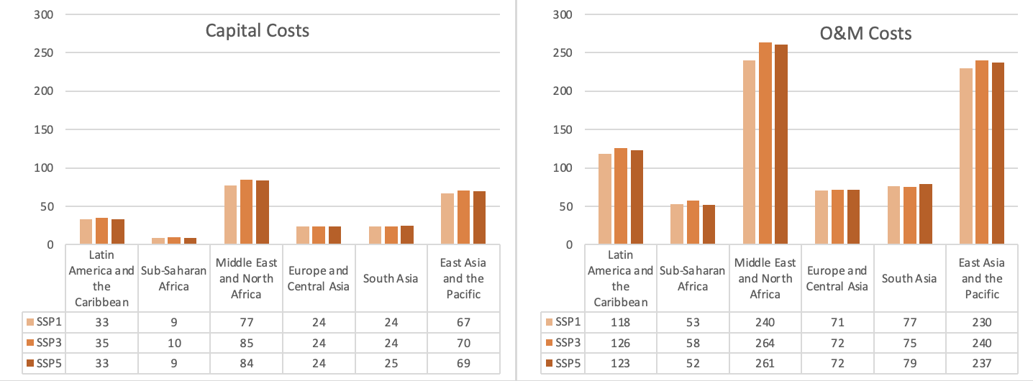

Figure 7 presents the annual costs of adapting new safely managed water supply services in urban areas under the scenario that universal access is achieved in 2040. The annual capital costs in 131 L&MICs until 2050 is between US$655 million and US$687 million for different SSPs. The O&M costs are 50% higher than capital costs. Globally, this represents an increased cost of 6.6% for both capital and O&M as a proportion of the annual costs of achieving universal access (from Figure 4). Regions with the highest increases are MENA and South Asia. South Asia has the highest cost.
Figure 7. Annual costs of reducing drought risk for new coverage of safely managed water supply services in urban areas by 2040, with O&M until 2050 – capital costs (left side) and O&M costs (right side)
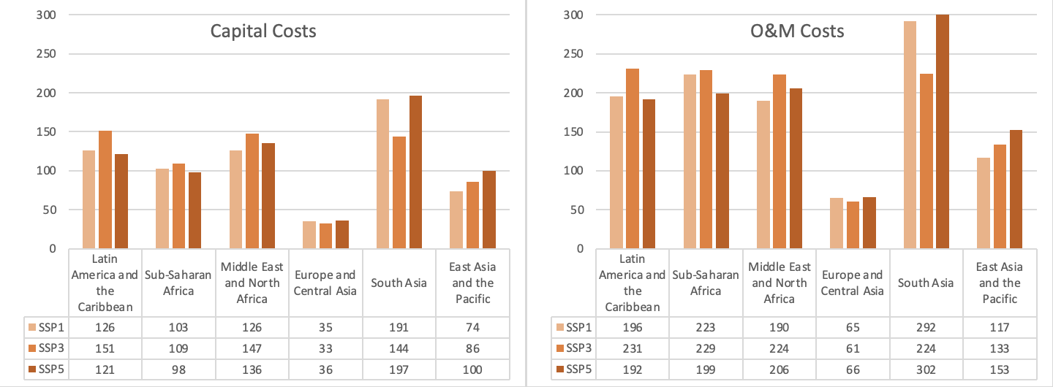
The costs of making new coverage climate resilient are greater than the costs of making existing coverage climate resilient in all regions. This is mainly due to population growth, and the assumption that all additional populations are counted as not being served.
Table 9 presents the results of the sensitivity analysis in which cost proportions were varied for water sourcing, conveyance, treatment and distribution, and the main water source proportions were varied. When more of the cost proportion was shifted to water treatment, it reduced the costs of retrofitted and new facilities from US$3 billion to US$1.86 billion for drought response; while for flood response it reduced to $2.3 billion. When water sources were adjusted to be more locally available, costs of drought response reduced by around half a billion to US$2.5 billion.
Table 9. Results of sensitivity analysis on cost and water source proportions for drought and flood resilience (US$ millions, annually)
Total cost estimate affected | Baseline result | Drought |  | Flood
Total cost estimate affected | Baseline result | Cost proportions | Water sources | Cost proportions
3. Retrofitting existing water services | $1,139 | $702 | $933 | $1,145
5. Ensuring new water services are climate resilient | $1,876 | $1,158 | $1,538 | $1,187
Sum 3. and 5. | $3,015 | $1,860 | $2,471 | $2,332

Costs of protecting water services from flood risks. Figure 8 presents the annual costs of adapting existing safely managed water supply services in urban areas. The annual capital costs in 131 L&MICs until 2050 varies US$11.9 to US$14.9 million between SSP2 and SSP3 including both medium and high risk. The O&M costs are between 3 and 4 times higher, at between US$40 and US$45 million for SSP2 and SSP3, respectively. Globally, this represents only an increased in cost of 0.14% for capital and 0.26% for O&M as a proportion of the annual costs of achieving universal access (from Figure 4).
Figure 8. Annual costs of reducing flood risk for existing safely managed water supply services in urban areas by 2040, with O&M until 2050 – capital costs (left side) and O&M costs (right side)
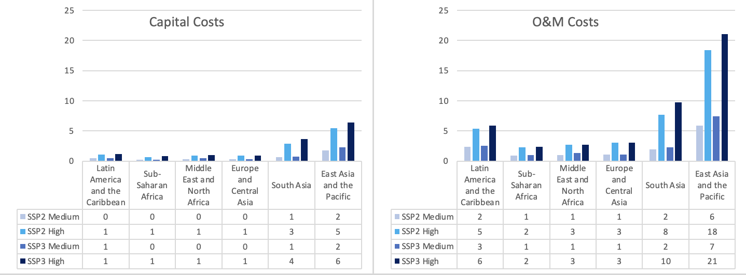

Figure 9 presents the annual costs of adapting new safely managed water supply services in urban areas under the scenario that universal access is achieved in 2040. The annual capital costs in 131 L&MICs until 2050 varies from US$14 to US$16 million for SSP2 and SSP3, respectively. The O&M costs are approximately 50% higher than capital costs. Globally, this represents only an increased in cost of 0.44% for capital and 0.34% for O&M as a proportion of the annual costs of achieving universal access (from Figure 4). When the costs are added together of making existing and new infrastructure drought resilient, it comes to 0.58% (capital) and 0.6% (O&M) of increasing access to the unserved.
Figure 9. Annual costs of reducing flood risk for new coverage of safely managed water supply services in urban areas by 2040, with O&M until 2050 – capital costs (left side) and O&M costs (right side)
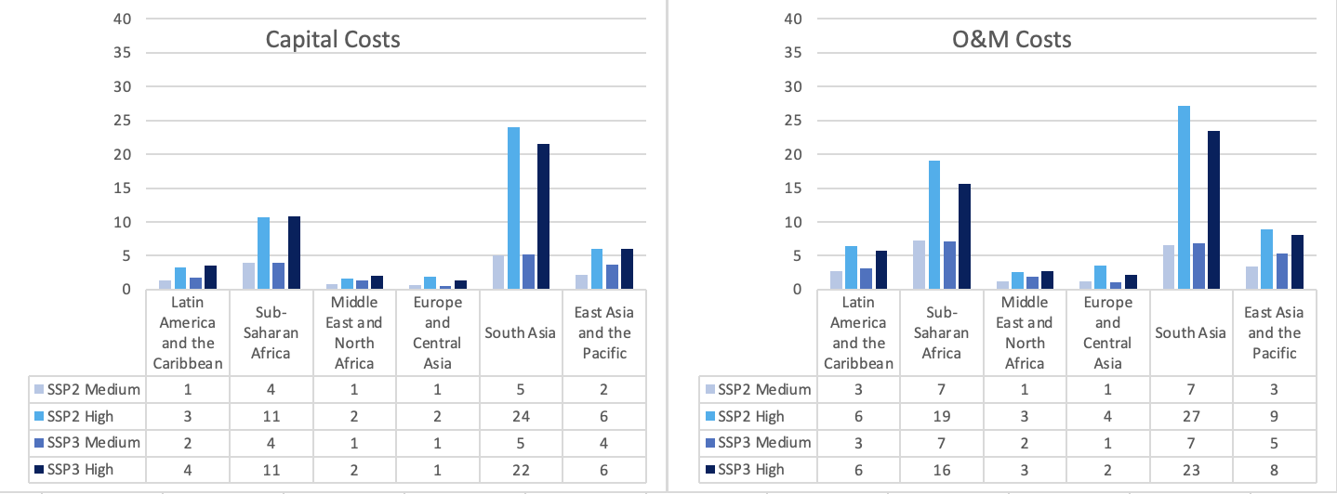

Combined costs of protecting from droughts and floods. Figure 10 shows the relative costs of drought versus flood resilience. Drought will affect a much greater population than floods, 2.1 billion versus 420 million, and also with a higher average cost premium for droughts – hence adapting for water scarcity will cost countries significantly more than floods.
Figure 10. Comparing the costs of drought and flood resilience under SSP3
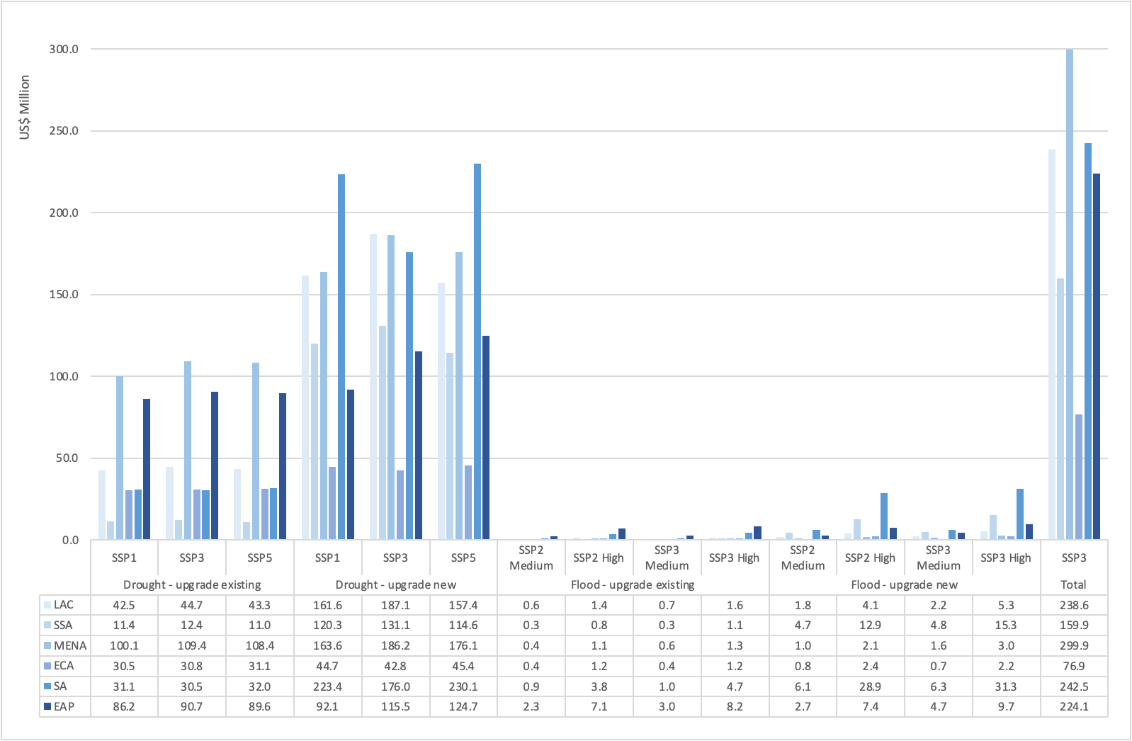
Costs of improving wastewater treatment. Figure 11 presents the annual costs of different wastewater management options. The costs of achieving universal access to wastewater treatment using current interventions is estimated at US$46.4 billion per year, counting both annuitized capital costs and O&M costs. Retrofitting existing wastewater treatment plants would be achieved at a cost of US$16.7 billion per year. Treating the current coverage gap with appropriate technologies to reduce GHG emissions would cost an additional US$27.1 billion per year. Ensuring all infrastructure is resilient to floods will cost an additional US$0.63 billion per year. The overall cost is US$90 billion per year, including both annualized capital and O&M costs. If every person had 100 liters of wastewater per day treated, it would lead to a minor reduction from US$90 billion to US$88.3 billion per year.
Figure 11. Annual costs of different wastewater/sludge treatment scenarios
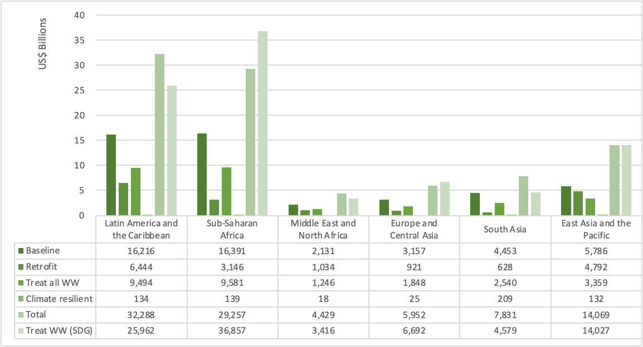

If the incremental costs of choosing low GHG emissions WWT technologies were 50% higher than the baseline cost instead of 100% higher, the costs of retrofitting would be reduced to US$8.5 billion and the costs of new infrastructure would be US$13.5 billion.
The global costs under SSP2 are US$2.9 billion higher than SSP2, at US$93.8 billion. Figure 12 presents the total wastewater costs by region, showing SSP2 is marginally more expensive in SSA, EAP and SA, but less expensive in LAC.
Figure 12. Total wastewater costs for SSP2 and SSP3, by region (US$ billions per year)
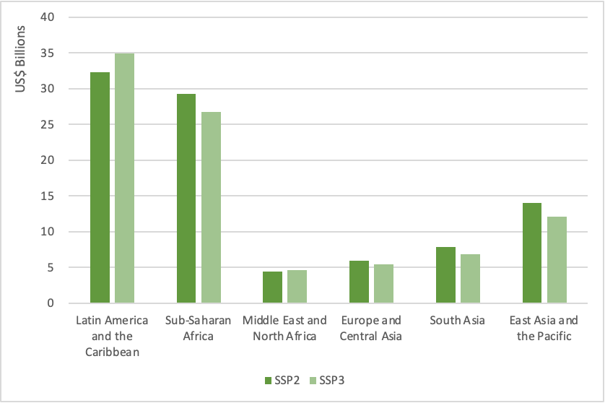
Current expenditure on urban water supply and wastewater treatment. Based on reported public expenditure from the UN-Water GLAAS survey 2021/2, Figure 13 shows the total expenditures by sub-sector for the 75 countries submitting financial data (representing 2.6 out of 3.4 billion urban population in L&MICs). The resulting estimates indicate that US$14.5 billion is spent from public funds on urban water supply in the latest year (2020 or 2021), or US$5.6 per capita in the 75 countries. When scaled up by the population covered in this study, it leads to a total value of US$19.0 billion spent on urban water supply per year, or US$7.3 per capita. This includes expenditures on both existing services and service extension.
Figure 13. Estimates of reported expenditures on water supply and sanitation, with rural/urban breakdown (US$ billion, latest reported year).
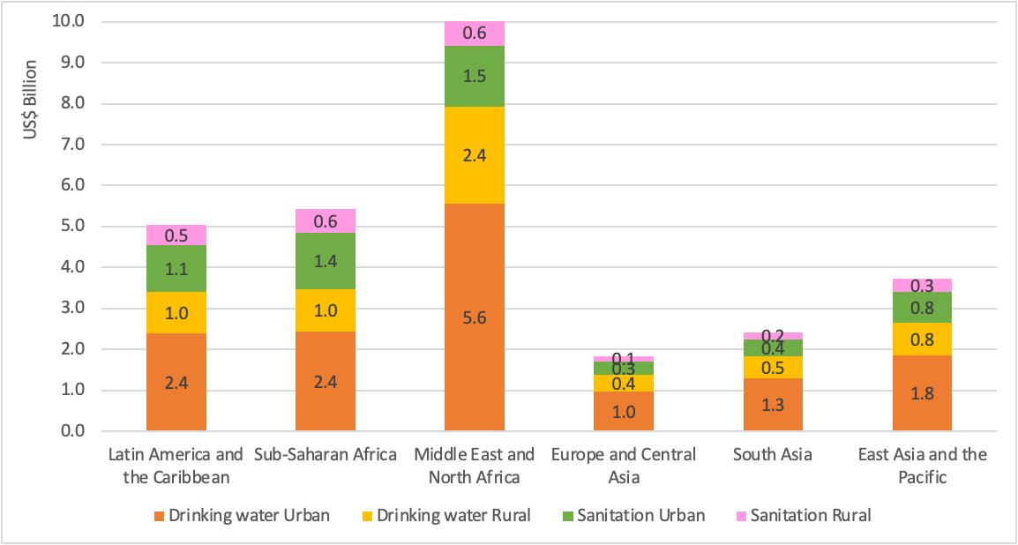

Using the cost estimation method (based on what would have been spent to achieve recent progress), it is estimated that US$9 billion has been spent annually to close the service gap from 2015 to 2022. Figure 14 shows the estimated expenditures on capital and O&M costs separately and for basic and safely managed water supply. Given the spending in Figure 10 are based on real data, however imperfect, the estimate of US$19 billion is used in this study instead of the US$9 billion in Figure 14.
Figure 14. Estimated expenditures on service expansion to achieve rates of progress in urban water supply from 2015 to 2022 (US$ million)
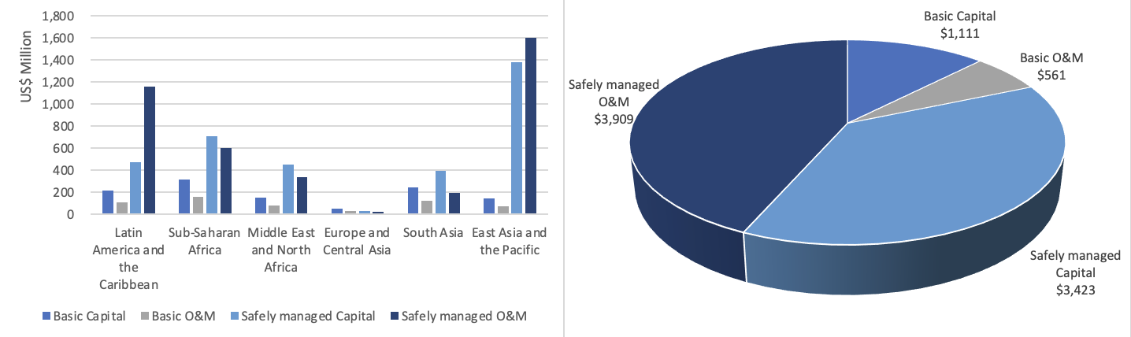
In terms of adequacy, 13 countries reported the annual need versus the annual available finance for urban drinking water to the UN-Water GLAAS survey. Overall, US$4.3 per year was financed out of US$7 billion per year needed, or 61%. As shown in Figure 15, most countries have a considerable gap, while some have no gap.
Figure 15. Finance needed versus finance available (US$ millions, annual)
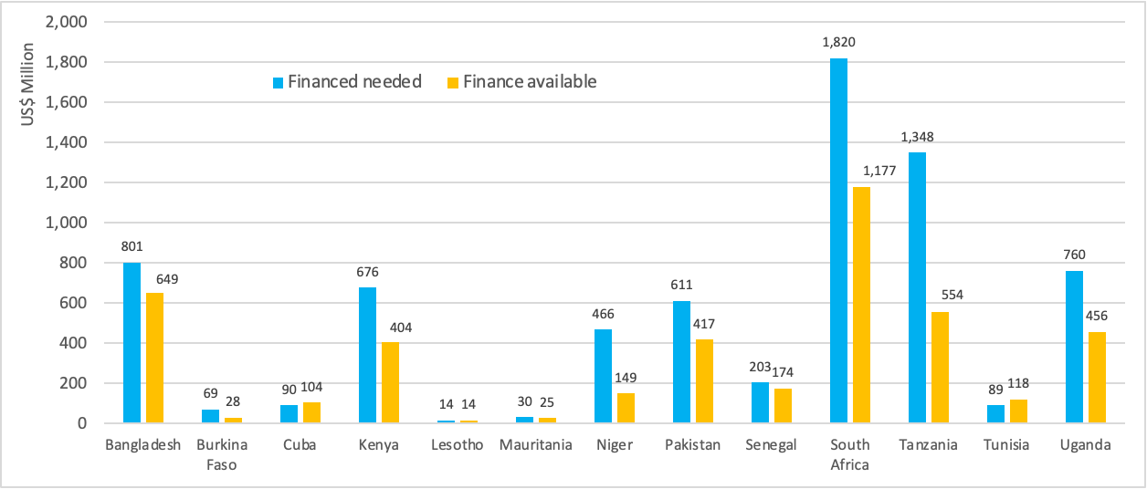
Source: UN-Water GLAAS Survey 2021/2, country data set

3.2 Water supply service level
Figure 16 shows the incremental costs of achieving flood and drought resilience under the assumption of the unserved population (limited or no surface water) receiving only the basic water service level. The costs are for capital costs only. Globally, it will cost US$714 million per year until 2050 to achieve universal basic WASH by 2030 and keep investing in infrastructure to cover population growth. This represents only 5.8% of the cost of achieving safely managed services, explained by both higher unit costs and greater population numbers to receive safely manged services compared to basic services. To reach universal access to basic services by 2030 itself over 7 years would cost US$16 billion or US$2.3 billion per year, comparing with US$5.5 billion per year in the previous World Bank study (Hutton and Varughese, 2016). The reduction in this present study is due to the continued growth in basic service coverage from 2015 to 2023. Sub-Saharan Africa accounts for over half these costs.
To achieve climate resilience of basic water services, the greatest costs are to upgrade existing infrastructure, with a global cost from US$164 to US$175 million per year for drought resilience (variable by SSP) and from US$7.6 to US$9.1 million for flood resilience. As shown in Figure 16, the highest regional costs are in LAC, MENA and EAP regions.
When taken together, the costs of drought and flood resilience for existing and new facilities, the global costs are US$230 million per year under SSP3, which adds 32% to the baseline costs of achieving universal access to basic water supply.

Figure 16. Costs of incremental costs of achieving flood and drought resilience per shared socio-economic pathway for basic water service level.
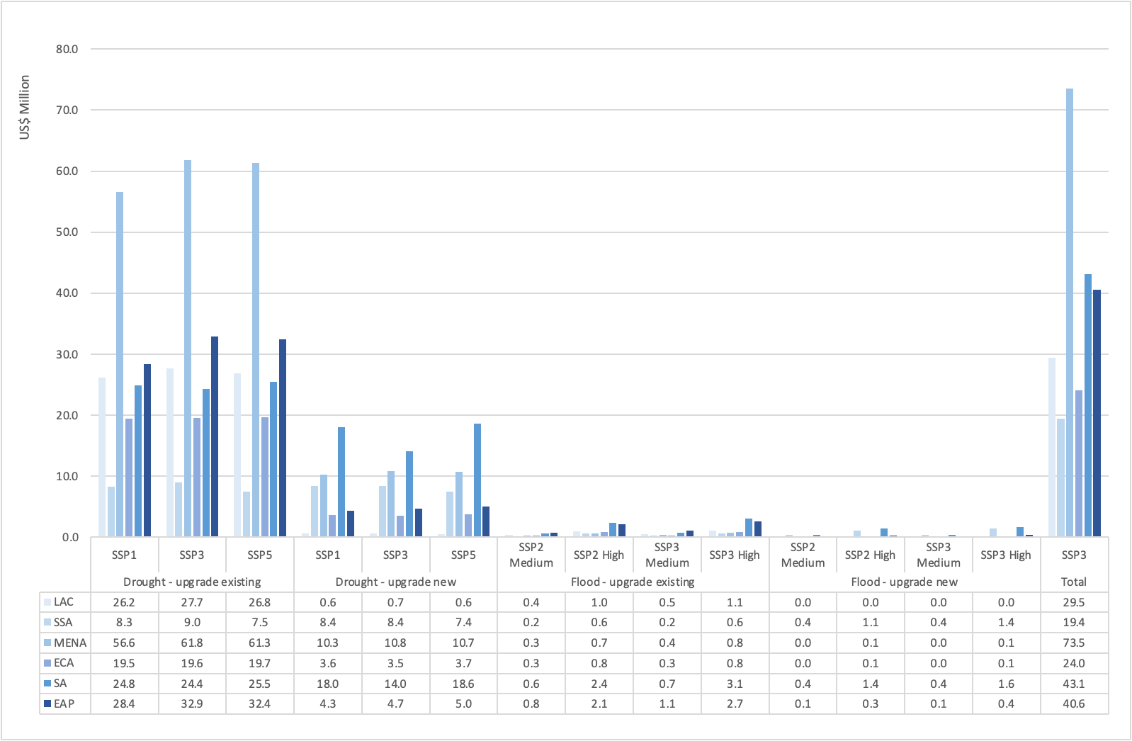

3.3 Population at risk of drought
For drought resilience, a threshold has to be drawn on what level of risk resilience needs to be planned for. In the baseline analysis presented above, populations with a risk of 40% or greater were included. If the medium-high risk category is included (i.e., 20-40%) there are marginal cost increases. Globally, the capital costs increase from US$ 920 million to US$1.1 billion per year. Figure 17 shows the regional contributors, with the biggest contributions in the increase coming from EAP, LAC and SSA.
Figure 17. Annual capital costs from 2024 to 2050, comparing 2 different drought risks (US$)
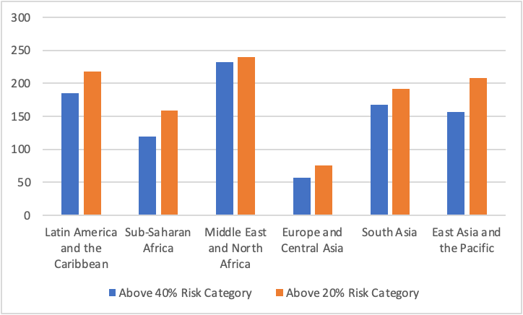

3.4 Target year for achieving water supply objectives
While the key results in section 3.1 show costs under a 2040 target, Figure 18 shows the results under three target years for achieving (and maintaining) universal access, under SSP3. The figure are annual averages, with all capital costs included until 2050, considering continued population growth. While Figure 18 shows regional results, at the global level the capital costs are higher in 2030, due to the frontloading of the investments and the effect of discounting. For example, the cost of upgrading new infrastructure for drought resilience costs US$150 million more per year from 2024 to 2050 (US$1.12 billion versus 0.95 billion) if the target year is 2030 instead of 2040. Making all services resilient to both droughts and floods will cost US$440 million per year more if the target year is 2030 compared to 2050. However, these higher costs should not deter governments and investors from accelerating progress, due to the high socio-economic of investing now and avoiding service disruptions.
Figure 18. Incremental costs of achieving safely managed service targets with climate resilience comparing three target years (2030, 2040, and 2050) under SSP3.
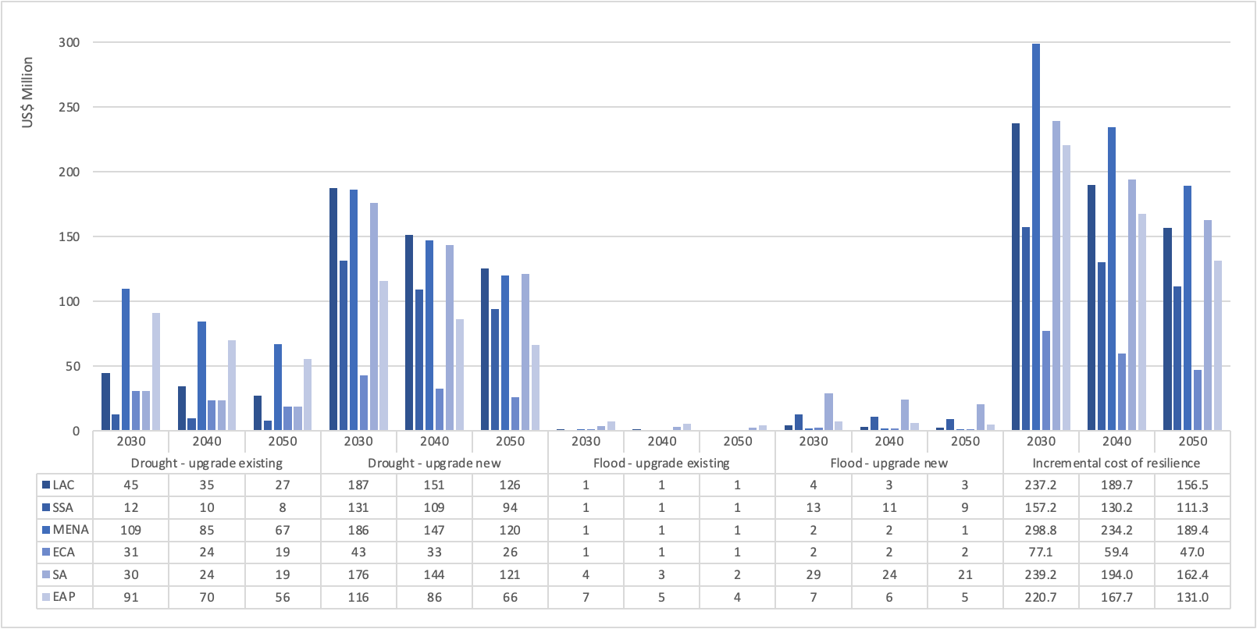

3.5 Discounting future water supply costs
When future costs are undiscounted, the overall costs are roughly 63% higher than when future costs are discounted at 6% per year to the baseline year of 2024. Under SSP3 and with a universal coverage target year of 2040, the global costs of achieving universal safely managed water supply are US$14.9 billion with no discounting and US$9.1 billion with discounting. The incremental costs of making these services resilient to climate change are US$1.58 billion with no discounting and US$975 million with discounting, which is 62% higher with no discounting. The difference in regional costs are shown for different scenarios in Figure 19.

Figure 19. Safely managed costs compared with versus without discounting future costs, under SSP3 and 2040 target year
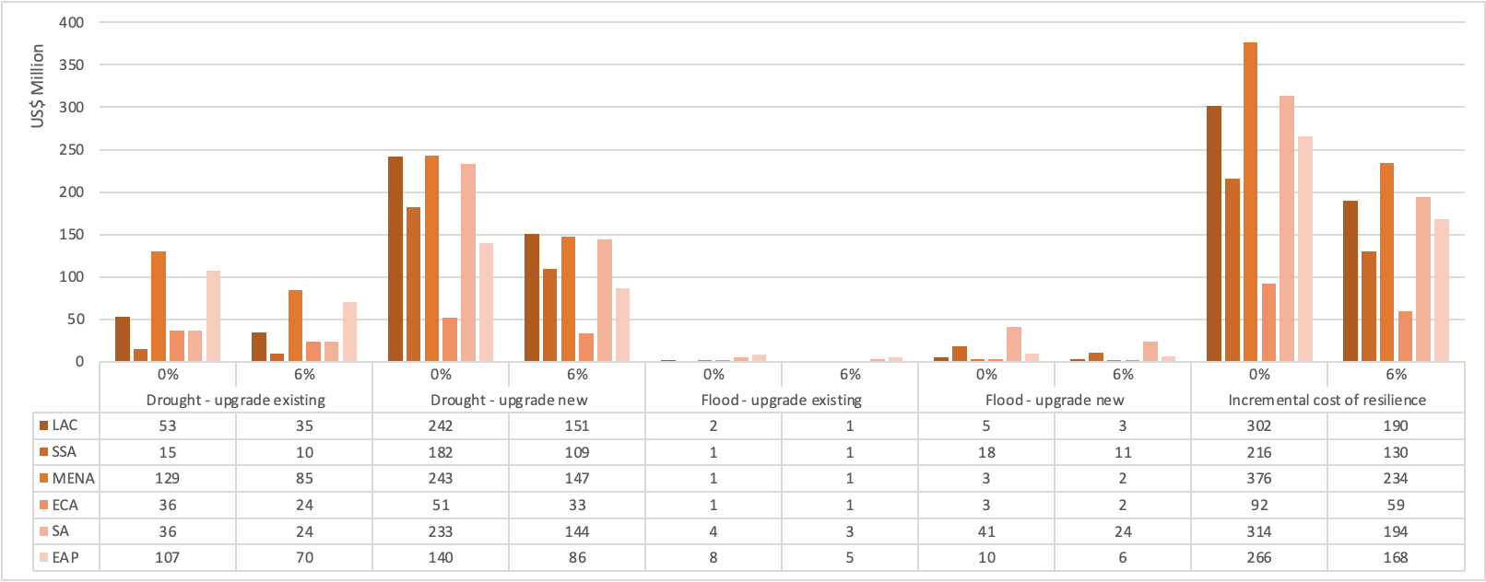

3.6 Total costs from 2030 to 2050
While annual costs are useful to compare with current budgets to conclude how much expenditure has to change to meet the targets, it is also useful to know the total costs, given that trajectories might not be linear and acceleration might take time to achieve. Figure 20 shows the total capital costs of achieving climate resilience from 2024 to 2050, with a 6% discount rate. The capital costs of achieving universal access of safely managed water are US$334 billion for capital costs and US$605 billion for O&M, thus totalling US$939 billion over 27 years. To make these services climate resilient, the greatest capital cost is related to upgrading new infrastructure for drought resilience – an additional US$17.7 billion (SSP1), US$18.1 billion (SSP3) to US$18.5 billion (SSP5) – in total from 2024 to 2050. The incremental capital costs from 2024 to 2050 of making urban water services resilient to drought and flood risk is US$26.3 billion, or a 7.9% increase on the baseline cost.
Figure 20. Total capital costs of achieving resilient water supply under different SSPs and target year 2040
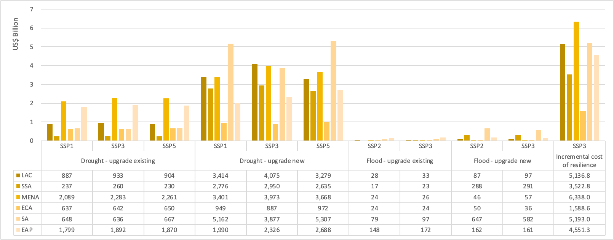

It should be noted that the immediate needs for capital investment in wastewater treatment are significantly greater than the numbers presented in section 3.1, as faster progress is needed than is accounted for when using annuitized figures, which reflect an annual depreciation value over the full lifetime of the infrastructure. If a 30-year lifetime was instead squeezed into a 7 year period by 2030, the capital cost needs would be US$40 billion per year for business as usual and an addition US$38 billion to achieve greater climate resilience, or a total cost of US$545 billion over 7 years.

3.7 Per capita costs
Figure 21 (left side) presents the annual cost per capita of achieving universal access without resilience, varying from US$2 per capita in EAP to US$14 per capita in SSA, covering the years 2024 to 2050 and achieving universal coverage in 2040. The global average is US$6 per capita per year. Figure 21 (right side) presents the incremental costs of achieving resilience, varying from US$0.46 in EAP to US$2.27 in MENA. The global average is US$0.75 per capita per year.
Figure 21. Costs per capita population for achieving universal access (left side) and resilience (right side) (US$)
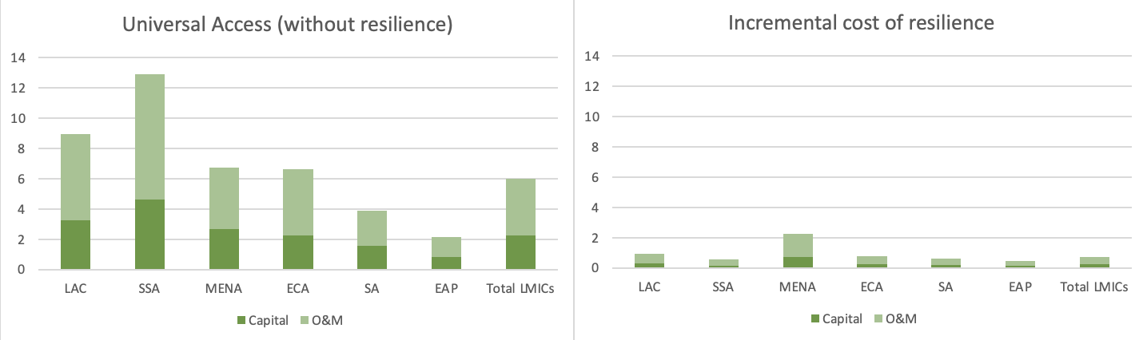

The per capita annual costs for wastewater management are presented in Figure 22. Overall, climate resilience accounts for about half the total costs, but varies from region to region. The highest per capita costs are in LAC at US$59, and the least cost is in South Asia with US$7.7 per capita.
Figure 22. Costs per capita (total population) for achieving universal access and climate resilience of wastewater management (US$)
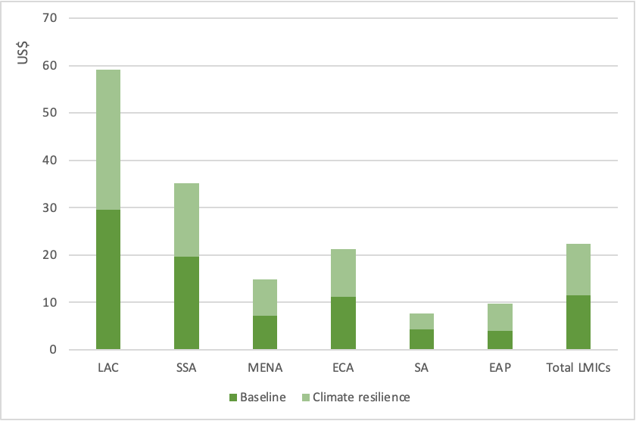

4. Key takeaways, limitations and conclusions
The world’s urban population faces a dual challenge in the face of limited public budgets and customer ability to pay: one challenge is to extend water supply services so that every urban household has access to a safely managed water supply; the other challenge is to make all urban water supply services resilient so that they can withstand climate and other shocks. This study has therefore focused on estimating the costs of providing universal access to climate resilient urban water supply services in 131 low- and middle-income countries (L&MICs) across 6 world regions, and the study has also provided cost estimates for extending climate resilient wastewater infrastructure. The costs include both capital and operations and maintenance (O&M) costs.
Using the Shared Socioeconomic Pathways 3 (SSP3) as an example, the annual costs of achieving universal access to urban water supply services is US$24.7 billion per year from 2024 until 2050 (37% capital cost and 63% O&M cost). However, this estimate is a business-as-usual scenario in which making water supply services resilient to the expected increase in droughts and floods is not taken into account. Therefore, the incremental costs of retrofitting existing water and wastewater facilities equals US$18.1 billion per year, or an increase on baseline costs of 25.4%. The incremental costs of ensuring new water and wastewater facilities for unserved populations are climate resilient will cost US$2.5 billion per year, or an increase on baseline costs of 3.5%. Together, the incremental costs are US$20.6 billion per year, or an increase on baseline costs of 28.9%. The current spending of approximately US$19 billion per year covers 77% of the current needs. However, as the majority of current spending is spent on operating existing services, and not extending services, the finance gap is significantly greater.
With the inclusion of several cost categories for water supply and wastewater treatment across 131 countries, and relying on globally available data sets, there are several methodological and data weaknesses which need to be taken into account when interpreting the results. First, the costs of service extension are based on updated estimates from a study conducted 10 years ago using inflation rates. As well as the weaknesses of the original global cost study, updating cost estimates by 10 years can introduce significant uncertainty into the estimates. Additional unit cost data were sourced for the wastewater study, with uncertainties in the national representativeness of data from few utilities across entire countries. Second, the costs of making services climate resilient are based on generalized cost premiums applied equally to all countries. However, there will be considerable variability between countries. Third, while the population at risk from droughts are floods are based on latest available information from widely used climate models, there remains considerable uncertainty in climate predictions. Furthermore, populations ‘at risk’ were defined using a cut-off point, whose value has limited scientific basis. Fourth, the urban population projections to 2050 vary considerably between SSPs – and again, have considerable uncertainty. Taken together, these four and other uncertainties means that the estimates presented in this report are indicative of the costs of achieving climate resilience. For example, a cost increase of 40% over business-as-usual can be instructive for decision makers now faced with budget allocations decisions, highlighting the need to consider carefully the future climate risks.
In conclusion, this study has demonstrated that considerable additional finance is required to make urban water services resilient to increasing climate risks, as well as fill the infrastructure maintenance backlog and close the existing service gap. It makes economic and financial sense to start acting now rather than to wait until more extreme climate impacts are felt, as by then it will involve considerably greater costs to retrofit infrastructure.

References
Arup (2015). The Future of Urban Water: Scenarios for Urban Water Utilities in 2040.
Awad H, Gar Alalm M, El-Etriby HK (2019). Environmental and cost life cycle assessment of different alternatives for improvement of wastewater treatment plants in developing countries. Sci Total Environ. 660: 57-68.
Berland JM and Cooper PF. (2001). Extensive Wastewater Treatment Processes Adapted to Small and Medium Sized Communities (500 to 5000 Population Equivalents). Office of Official Publications of the European Union, Luxembourg.
Beveridge G (2022). The Costs of Drought in Urban Water Supply Planning. MSc Thesis. University of Auckland. https://researchspace.auckland.ac.nz/bitstream/handle/2292/63443/Beveridge-2022-thesis.pdf?sequence=1
Cheng S, Long J, Evans B, Zhan Z, Li T, Chen C, Mang HP, Li Z (2022). Non-negligible greenhouse gas emissions from non-sewered sanitation systems: A meta-analysis. Environ Res. 212(Pt D):113468.
Damania R, Desbureaux S, Hyland M, et al (2017). Uncharted Waters: The New Economics of Water Scarcity and Variability. Washington, DC: World Bank. doi:10.1596/978-1-4648-1179-1. License: Creative Commons Attribution CC BY 3.0 IGO
Decker C (2018). Analysis of the costs of water resource management options to enhance drought resilience. Final Report for the National Infrastructure Commission, UK. Regulatory Economics.
Dilling L, Daly ME, Kenney DA, R Klein, et al (2019). Drought in urban water systems: Learning lessons for climate adaptive capacity. Climate Risk Management 23: 32-42.
Dogot T, Xanthoulis Y, Fonder N, Xanthoulis D (2010). Estimating the costs of collective treatment of wastewater: the case of Walloon Region (Belgium). Water Sci. Technol. 62(3):640–648.
Ehalt Macedo H, Lehner B, Nicell JA, Grill G et al (2021). Global distribution of wastewater treatment plants and their released effluents into rivers and streams. Earth System Science Data. https://essd.copernicus.org/preprints/essd-2021-214/essd-2021-214.pdf
Gallego-Schmid A, Zepon Tarpani RR (2019). Life cycle assessment of wastewater treatment in developing countries: A review. Water Research 153: 63-79.
Gao J 2020. Global 1-km Downscaled Population Base Year and Projection Grids Based on the Shared Socioeconomic Pathways, Revision 01. Palisades, New York: NASA Socioeconomic Data and Applications Center (SEDAC). https://doi.org/10.7927/q7z9-9r69. Accessed 18 March 2024.
Gu D, Liu Y, Zhao W, Qiu S, et al (2023). Status of Research on Greenhouse Gas Emissions from Wastewater Collection Systems. Water 15:2512. https://doi.org/10.3390/w15142512
Gutierrez J (2019). Water Scarcity and Supply Challenges in Mexico City's Informal Settlements. Penn Institute for Urban Research. https://penniur.upenn.edu/uploads/media/02_Gutierrez.pdf
Hallegatte S, Rentschler J, Rozenberg J (2019). Lifelines: The Resilient Infrastructure Opportunity. Sustainable Infrastructure Series. Washington, DC: World Bank. doi:10.1596/978-1-4648-1430-3. License: Creative Commons Attribution CC BY 3.0 IGO
Hernández-Sancho F, Lamizana-Diallo B, Mateo-Sagasta J, Qadir M (2015). Economic Valuation of Wastewater - The cost of action and the cost of no action. United Nations Environment Programme.
Hernández-Hernández M, Olcina J, Morote Á-F. Urban Stormwater Management, a Tool for Adapting to Climate Change: From Risk to Resource. Water. 2020; 12(9):2616.
Heyman JM, Mayer A, Alger J (2022). Predictions of household water affordability under conditions of climate change, demographic growth, and fresh groundwater depletion in a southwest US city indicate increasing burdens on the poor. PLoS One 17(11):e0277268.
Hu X, Pant R, Zorn C, Lim W, et al (2019). Methodology and Findings for the Exposure Analysis of the Chinese Wastewater Sector to Flooding and Earthquakes Hazards. Background paper for World Bank “Lifelines” report, Washington, DC.
Huberts A, Palma D, Bernal García AC, Cole F, Roberts EFS (2023) Making scarcity “enough”: The hidden household costs of adapting to water scarcity in Mexico City. PLOS Water 2(3): e0000056.
Hughes G, Chinowsky P, Strzepek K (2010). The costs of adaptation to climate change for water infrastructure in OECD countries. Utilities Policy 18: 142-153.
Hutton, Guy and Varughese, Mili (2016). The Costs of Meeting the 2030 Sustainable Development Goal Targets on Drinking Water, Sanitation, and Hygiene. Water and Sanitation Program, World Bank.
Hutton G (2022). Chapter “SDG 6 global financing needs and capacities to ensure access to water and sanitation for all.” In “Investing in Water and Growth. Recent developments and perspectives” – Edited Leflaive X, Dominique K, Alaerts G. Published by Elsevier.
Iglesias R, Ortega E, Batanero G, Quintas L (2010). Water reuse in Spain: Data overview and costs estimation of suitable treatment trains. Desalination 263(1-3):1-10.
IWA (International Water Association) (2015) Reduction of non-revenue water around the world. https://iwa-network.org/reduction-of-non-revenue-water-around-the-world/
Kuzma, S., M.F.P. Bierkens, S. Lakshman, T. Luo, L. Saccoccia, E. H. Sutanudjaja, and R. Van Beek. 2023. “Aqueduct 4.0: Updated decision-relevant global water risk indicators.” Technical Note. Washington, DC: World Resources Institute. Available online at: doi.org/10.46830/writn.23.00061
Leverenz HL, Tchobanoglous G, Darby JL (2010). Evaluation of Greenhouse Gas Emissions from Septic Systems. 2010 by the Water Environment Research Foundation. Published by IWA.
Li L, Wang X, Miao J, Abulimiti A, Jing X, Ren N (2022). Carbon neutrality of wastewater treatment - A systematic concept beyond the plant boundary. Environ Sci Ecotechnol. 9(11):100180.
Libey A, Adank M, Thomas E (2020). Who pays for water? Comparing life cycle costs of water services among several low, medium and high-income utilities. World Development 136: 105155.
Liemberger R, Wyatt A (2019) Quantifying the global non-revenue water problem. Water Sci Technol Water Supply 19(3):831–837.
Miyamoto International Inc. (2019). Overview of Engineering Options for Increasing Infrastructure Resilience. Miyamoto International Inc. and World Bank Group.
Moral Pajares E, Gallego Valero L, Román Sánchez IM (2019). Cost of Urban Wastewater Treatment and Ecotaxes: Evidence from Municipalities in Southern Europe. Water 11(3):423.
Morote AF, Hernández M (2017). El uso de aguas pluviales en la ciudad de Alicante. De Viejas ideas a nuevos enfoques. Pap. Geogr. 63:7–25.
Nkiaka E, Bryant NE, Okumah M, Faith-Gomo F (2021). Water security in sub-Saharan Africa: Understanding the status of sustainable development goal 6. Wiley Interdisciplinary Reviews: Water 8(6):e1552.
Ong C, Tortajada C, Arora O (2023). Key Challenges to Urban Water Management in ASEAN. In: Urban Water Demand Management. Springer Briefs on Case Studies of Sustainable Development. Springer, Singapore.
Parravicini V, Svardal K, Krampe J (2016). Greenhouse Gas Emissions from Wastewater Treatment Plants. Energy Procedia 97: 246-253.
Prateep Na Talang R, Sirivithayapakorn S, Polruang S (2022). Life cycle impact assessment and life cycle cost assessment for centralized and decentralized wastewater treatment plants in Thailand. Sci Rep. 12(1): 14540.
Pryce D, Kapelan Z, Memon FAA (2022). Economic evaluation of a small wastewater treatment plant under different design and operation scenarios by life cycle costing. Development Engineering 7: 100103.
Rentschler J, Salhab M, Jafino BA (2022). Flood exposure and poverty in 188 countries. Nat Commun 13: 3527.
Ribeiro FW, da Silva SMO, de Souza Filho F, Carvalho TMN, de M. Lopes TMX (2022). Diversification of urban water supply: An assessment of social costs and water production costs. Water Policy 24(6): 980–997.
Rodriguez-Garcia G, Molinos-Senante M, Hospido A, Hernández-Sancho F, Moreira MT, Feijoo G (2011). Environmental and economic profile of six typologies of wastewater treatment plants. Water Research 45(18): 5997-6010.
Rozenberg J, Fay M (eds)(2019). Beyond the Gap: How Countries Can Afford the Infrastructure They Need while Protecting the Planet. Sustainable Infrastructure Series. Washington, DC: World Bank. doi:10.1596/978-1-4648-1363-4. License: Creative Commons Attribution CC BY 3.0 IGO.
Salameh E, Al-Alami H (2021) Jordan’s Water Sector—Alarming Issues and Future. Journal of Geoscience and Environment Protection, 9, 100-117.
Sekandari AW (2019). Cost Comparison Analysis of Wastewater Treatment Plants. International Journal of Science Technology & Engineering 6(1): 65-73.
Silva Pinto F, de Carvalho B, Cunha Marques R (2021). Adapting water tariffs to climate change: Linking resource availability, costs, demand, and tariff design flexibility. Journal of Cleaner Production 290: 125803.
Shaw K, Kennedy C, Dorea CC (2021). Non-Sewered Sanitation Systems’ Global Greenhouse Gas Emissions: Balancing Sustainable Development Goal Tradeoffs to End Open Defecation. Sustainability 13(21):11884.
Strong C, Kuzma S, Vionnet S, Reig P (2020). Achieving Abundance: Understanding the Cost of a Sustainable Water Future. Working Paper. Washington, DC: World Resources Institute.
The CEO Water Mandate (2014). Driving Harmonization of Water-Related Terminology. Discussion Paper, September 2014. The Global Compact. Pacific Institute.
van Vliet MTH, Sheffield J, Wiberg D, Wood EF (2016). Impacts of recent drought and warm years on water resources and electricity supply worldwide. Environmental Research Letters, 11(12), Article 124021.
Wang D, Ye W, Wu G et al (2022). Greenhouse gas emissions from municipal wastewater treatment facilities in China from 2006 to 2019. Sci Data 9: 317.
World Bank. 2020. Resilient Water Infrastructure Design Brief. World Bank, Washington, DC.
Wang D, Ye W, Wu G et al. Greenhouse gas emissions from municipal wastewater treatment facilities in China from 2006 to 2019. Sci Data 9, 317 (2022). https://doi.org/10.1038/s41597-022-01439-7
Wu Z, Duan H, Li K, Ye L (2022). A comprehensive carbon footprint analysis of different wastewater treatment plant configurations. Environ Res. 214(Pt 2):113818.

Other materials
Article: “Water Stress: A Global Problem That’s Getting Worse” – Council on Foreign Relations. April 2023 https://www.cfr.org/backgrounder/water-stress-global-problem-thats-getting-worse
Article: “Here’s where water is running out in the world — and why” August 2023. https://www.washingtonpost.com/climate-environment/interactive/2023/water-scarcity-map-solutions/
Article: “Egypt has a water problem—and no, it’s not only the GERD” by Yaniv Cohen, June 2021. https://www.atlanticcouncil.org/blogs/menasource/egypt-has-a-water-problem-and-no-its-not-only-the-gerd/

Endnotes

https://datahelpdesk.worldbank.org/knowledgebase/articles/906519-world-bank-country-and-lending-groups
West Bank & Gaza and Ukraine were excluded due to lack of data on costs and unknown water service coverage following current conflict. Kosovo was excluded due to no urban water coverage rates and no cost data from previous World Bank WASH cost study (Hutton and Varughese, 2016).
https://sedac.ciesin.columbia.edu/data/set/popdynamics-1-8th-pop-base-year-projection-ssp-2000-2100-rev01
Under the three scenarios modelled, urban population in 2050 grows to 5.1 billion for SSP1, 4.2 billion for SSP3 and 5.1 billion for SSP5.
https://washdata.org/
https://www.unwater.org/publications/progress-wastewater-treatment-2021-update
https://data.worldbank.org/indicator
Costs of improving the (finance) enabling environment are important to include, given the challenges of raising the finance for these additional investments. These costs are available from some countries, and a simplification will be made based on available evidence and expert judgement (e.g., a certain % increase on the infrastructure costs).
See Hutton (2022) for an overview of these studies.
While the analysis could adopt different target years for different countries based on the realism (e.g., based on the baseline rate, current rate of progress, and level of economic development), it seems unnecessary for a global analysis to make such judgements, which introduce a further level of subjectivity to the results.
Costs in 2015 USD were converted to each country’s national currency using average official exchange rates for 2015; the costs were then converted to 2024 prices using the GDP deflator each year (for recent years we assumed the same rate as the latest year of data); the costs were then converted back to USD using the average official exchange rates for 2022.
https://en.wikipedia.org/wiki/Representative_Concentration_Pathway
Dry shock: rainfall that is at least 1 standard deviation below normal levels (e.g. the Standard Precipitation Index) – Damania et al, 2017. Perennial water shortages: less than 100 liters per person per day of sustainable surface water or groundwater – Damania et al, 2017. Physical water scarcity: lack of volumetric abundance of freshwater resources (not considering whether it is of appropriate quality for use) – CEO Water Mandate, 2014. The FAO AQUASTAT database provides global data, and different degrees of water scarcity categorise countries based on thresholds (e.g., no stress, stress, high stress). Water stress: lack of ability to meet human and ecological demand for freshwater, including water availability, water quality, and the accessibility of water (sufficiency of infrastructure and affordability) – CEO Water Mandate, 2014. Water risk: the possibility of an entity experiencing a water-related challenge (e.g., water scarcity, water stress, flooding, infrastructure decay, drought), with the extent of risk being a function of the likelihood of a specific challenge occurring and the severity of the challenge’s impact – CEO Water Mandate, 2014.
In 2023, 85 million people in urban areas used limited water supply (improved >30 minutes roundtrip), 57 million people in urban areas used unimproved water sources; and 10 million people in urban areas used surface water.
https://www.wri.org/applications/aqueduct/water-risk-atlas/#/?advanced=false&basemap=hydro&indicator=1b4f2592-09fd-4ac4-afcd-5a0a9a63617b&lat=18.895892559415024&lng=60.99609375000001&mapMode=view&month=1&opacity=0.5&ponderation=DEF&predefined=false&projection=absolute&scenario=business_as_usual&scope=future&threshold&timeScale=annual&year=2030&zoom=3
“SSP1–2.6 represents an “optimistic” scenario limiting the rise in average global surface temperatures by 2100 to 1.3°C to 2.4°C compared to preindustrial levels (1850–1900). SSP1 is characterized by sustainable socioeconomic growth: stringent environmental regulations and effective institutions, rapid technological change and improved resource efficiency, and low population growth (Wada et al. 2016). SSP3-7.0 represents a “business as usual” scenario with temperatures increasing by 2.8°C to 4.6°C by 2100. SSP3 is a socioeconomic scenario characterized by regional competition and inequality, including slow economic growth, weak governance and institutions, low investment in the environment and technology, and high population growth, especially in developing countries. SSP5-8.5 represents a “pessimistic” scenario with temperature increases up to 3.3°C to 5.7°C. SSP5 describes fossil-fueled development: rapid economic growth and globalization powered by carbon-intensive energy, strong institutions with high investment in education and technology but a lack of global environmental concern, and the population peaking and declining in the 21st century. Each scenario has varying effects on water availability in different parts of the world.” Extract from Kuzma et al, 2023.
https://climateknowledgeportal.worldbank.org/
Data have been collected by the UN-Water GLAAS survey (2021-22) for most L&MICs on whether a country addresses climate change in its WASH policies and plans. While 43% of countries answered that their policies and plans consider climate resilience of WASH technologies and management systems, it is unlikely that having a policy or plan means that they have been implemented. Conversely, services could also be drought resilience without a national policy or plan. 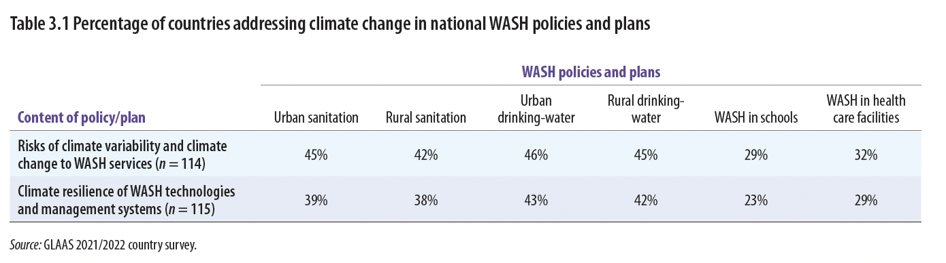
In many cities, groundwater has been depleted or being consumed at unsustainable rates, hence should only be relied on when it can be consumed at a renewable rate. In some locations, there are vast supplies of unexploited groundwater: https://theconversation.com/africas-aquifers-hold-more-than-20-times-the-water-stored-in-the-continents-lakes-but-they-arent-the-answer-to-water-scarcity-201704
Desalinization costs have reduced considerably over recent years. Salameh et al (2021) report costs as low as US$0.60 per m³ in Jordan. However, the energy costs and GHG emissions need to be factored in so that costs reflect the full social price.
https://ourworldindata.org/water-use-stress accessed 6 February 2024
Several examples of results achieved in addressing water scarcity were reported by Arup (2015): (1) the Zaragoza Water Commission in Spain has successfully implemented a water-saving culture within the city that has led to an almost 30% reduction in water consumption over 15 years. It includes water-saving technology as well as a reduction in wasteful water usage. (2) With one of the most efficient leakage prevention and maintenance systems in the world Tokyo has managed to more than halve its water loss within 10 years and minimised its leakage rate from 20% to 3.6%.
For example, in Mexico, a single ‘pipa’ (tanker truck) delivery of 10,000 liters of water usually lasted the family between one and two months and costs 950 pesos ($49.4 2019 USD) (Huberts et al, 2023). Purchase of ‘garrafones’ (20-liter jugs of drinking water) from local convenience stores cost about 40 pesos ($2.08 2019 USD), or from local water purifiers they cost about 15–30 pesos (about $0.78 or $1.56 in 2019 USD) (Huberts et al, 2023).
https://agenciadenoticias.ibge.gov.br/en/agencia-news/2184-news-agency/news/37059-em-2020-para-cada-r-1-00-gerado-pela-economia-foram-consumidos-6-2-litros-de-agua-2
Geophysical Fluid Dynamics Laboratory (GFDL) is a programme of the US National Oceanic and Atmospheric Administration (NOAA).
https://gadm.org/
https://www.unwater.org/our-work/integrated-monitoring-initiative-sdg-6/indicator-632-proportion-bodies-water-good-ambient
Based on a data set of 1,346 WWTPs in China. For an event with a 30-year return period under a scenario of moderate climate change, 35 percent of the WWTPs (472 out of 1,346 plants) supplying 176 million people could experience significantly higher flood risk by 2035. By 2055, the number of exposed people could rise by up to 208 million from the present number.
Based on a review of UN-Water TrackFin reports for Brazil, Ghana, Mali, and Morocco, where the division between water and sanitation and between urban and rural were found to be similar.
Water quality, water continuity and on-plot access.

